**BroodMinder User Guide**

*September 2019*

*Version 3.00*

*BroodMinder – Because Every Hive Counts*

# **Document Revisions**

|  |  |  |
| --- | --- | --- |
| Date | Version  Number | Document Changes |
| 1/28/2016 | 0.10 | Initial Draft |
| 1/29/2017 | 0.11 | Added Beekeeping.io and Database sections |
| 1/30/2017 | 0.12 | Fixed Graphs to fit on page and incorporate Theo’s updates |
| 2/2/2017 | 1.00 | Release to the world after a few typo corrections |
| 2/16/2017 | 1.01 | Add BLE advertising info to Appendix B |
| 2/26/2017 | 1.02 | Add scale temperature compensation info |
| 6/15/2017 | 2.60 | Update for version 2.60 app |
| 10/12/2017 | 2.70 | Update for version 2.70 app |
| 12/20/2017 | 2.77 | Update includes BroodMinder-APIARY app |
| 5/23/2018 | 2.90 | Cosmetic updates, new video pages, clarifications |
| 7/9/2018 | 2.91 | Correct a detail in the BLE advertising section |
| 11/20/2018 | 2.91 | Add BroodMinder-T2 and Android app controls |
| 1/3/2019 | 2.98 | Add Real Time Mode Notes & T2 turn off |
| 3/20/2019 | 2.99 | -T2 Upgrade info, Routine Maintenance |
| 8/27/2019 | 3.00 | Standard App version 3.00 information  Apiary App version 1.80 information |

Contents

**Document Revisions** ii

1 Introduction 5

1.1 Welcome 5

1.2 What’s New? 6

1.3 Quick Start if you plan to share your data (THANK YOU!) 7

1.3 Quick Start if you plan to keep your data private 8

1. Watch the video help that you will find at MyBroodMinder.com 8

2 Installing your BroodMinder – Location, Location, Location 9

2.1 Sensor Locations 9

2.3 BroodMinder-T2 10

2.3 BroodMinder-W 10

3 Routine Maintenance 13

3.1 Spring 13

3.1 Fall 13

4 Device Software Updates 13

5 The BroodMinder App 14

5.1 Device compatibility 14

5.2 Installation 14

5.3 Home Screen of BroodMinder App 15

5.4 Details/Graph Screen of BroodMinder App 16

5.5 General Setting Page 17

5.6 Device Setting Page 18

5.8 Real Time Mode 19

5.8 Setting the BroodMinder-W temperature compensation 21

5.9 Tagging Graphs 22

6 BroodMinder-APIARY App 23

7 MyBroodMinder.com Cloud Storage 27

8.1 Database operations 31

8.2 Send CSV (Comma Separated Value) Text File 31

8.3 Send SQLite file 33

8.4 Import HbH CSV or SQLite file 33

8.5 Import HbH CSV 34

8.6 Import SQLite File 34

8.7 Rebuild Database 34

8.8 Delete database 35

9 BroodMinder-WIFI & BroodMinder-CELL 36

For best results, watch the installation video at BroodMinder.com/pages/videos 36

10 Data Interpretation 46

10.1 Hive Weight Profiles 46

10.2 Swarm Detection with a BroodMinder TH Device in a Top Bar Hive 48

10.3 Avoiding Excessive Heat in the Hive During Summer Months 50

10.4 Detection of Cluster/Queen Movement and Spring Brood Buildup 52

10.5 Pull the Supers When the Dearth Hits 54

10.6 Promising Citizen Science Project Observations 56

10.7 Using BroodMinder Data to Optimize Hive Preparation for Winter 57

11 Appendices 59

11.1 Appendix A - BroodMinder-W physics 59

11.2 Appendix B – BLE advertising protocol 66

11.3 Appendix C – App updates 67

## 1 Introduction

### 1.1 Welcome

Congratulations on the purchase of your BroodMinder product. We are happy that you have joined our movement to improve bee health and to share data to enhance our understanding. This manual is intended to fill in any gaps to make your BroodMinder experience more pleasant and productive.

If you still have questions or suggestions, or just want to chat about bees, then contact us at support@broodminder.com. We are there to help.

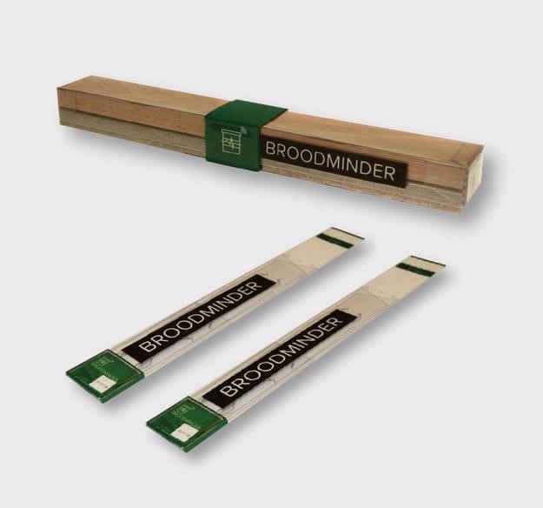

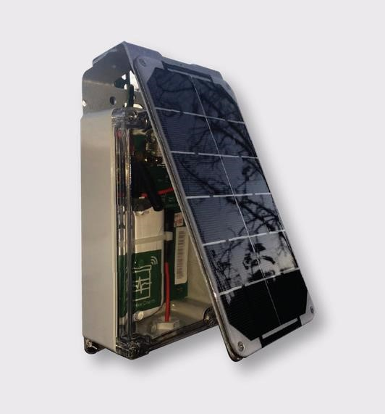

# 

### 1.2 What’s New?

There are many changes to the Apps and to MyBroodMinder in this update.

* Standard App
  + The addition of ‘Whack-A-Mite’. Check it out!
  + Support for BroodMinder-T2SwarmMinder (coming soon)
* Apiary app
  + Remote uploading – The apiary app now works with or without internet connectivity.
  + Hub mode – You can use any internet connected iOS or Android device to send data every 10 minutes from your apiary
  + CELL wakeup – The BroodMinder-CELL device can be taken out of deep sleep.
* MyBroodMinder.com - In July 2019 we introduced a new version of MyBroodMinder.com
  + New updated user experience
    - BroodMinder resources including a video help manual on home page
    - Improved apiary & hive navigation
    - Easy sharing of apiaries with others
  + Text/Hive/Summary views at apiary level
  + Powerful Configuration Manager
    - Easier to move device between hives
    - View and download device inventory
  + Data viewer/Outlier editor
  + Hub monitoring

## 1.3 Quick Start if you plan to share your data (THANK YOU!)

We have done our best to make the installation and usage of your BroodMinder intuitive and easy. Here are the basic steps that we will review in detail below.

1. **Watch the video help that you will find at**[**MyBroodMinder.com**](https://mybroodminder.com/).
2. **Load the** **BroodMinder Apiary App** to your cell phone or tablet. You will find 3 apps on the store. Choose the Apiary App. The other apps are described below and in the video user guide.
3. **Create a MyBroodMinder.com account** by going to [**MyBroodMinder.com**](https://mybroodminder.com/)[.](https://broodminder.com/pages/videos) Go ahead and create an apiary and hive if you have time. (You can do this step after installation.) You will receive 30 days of MyBroodMinder.com-Premium for joining.
4. **Activate the battery** in your BroodMinder device by pulling the tab (BroodMinder-TH) or snapping it in (BroodMinder-W) or pushing the button (BroodMinder-T2)
5. **Install your BroodMinder** into your hive.
   1. Place one BroodMinder-TH or -T2 on top of the frames in your lower brood box.
   2. Place a second BroodMinder-TH on top of the frames in your upper brood box.
   3. Place your BroodMinder-W under the front of the hive with a 2x4 or other pivot under the back (or vice-versa). Place the BroodMinder in the shady side so that the outside temperature reading is not affected by the sun.
6. **Open the apiary app** and wait for yours BroodMinder to appear.
   1. Go to settings (gear icon) and enter your MyBroodMinder.com information
   2. Return to the device list
7. **Retrieve the Hour-by-Hour (HbH) data** after the BroodMinder has been running for a couple of hours. (If you don’t have internet connectivity, go to the section on the Apiary App for further instructions.)
   1. Tap the cloud with the up arrow in the upper right corner of your screen.
   2. The app will present a status page and start collecting all of your BroodMinder data. You can work on your hives while it completes automatically.
8. **Share your data with the world**.
   1. After sync is complete, you will be asked to upload to the cloud. We hope that you will do this, it will benefit the entire beekeeping community.
   2. The first time, it will ask for an e-mail and password. The app will use this to create or use an existing MyBroodMinder.com login.
   3. Next you will identify the Apiary/ZIP and Hive that the device is in.
   4. Finally, the data will be sent to MyBroodMinder.com. Note that steps a through c only occur the first time you send data.
9. **That’s it, you are now part of the solution!**
10. **Bee sure and share** your hive data with your friends using our public domain viewer at **BeeCounted.org**

## 1.3 Quick Start if you plan to keep your data private

We have done our best to make the installation and usage of your BroodMinder intuitive and easy. Here are the basic steps that we will review in detail below.

### 1. Watch the video help that you will find at[MyBroodMinder.com](https://mybroodminder.com/)

1. **Load the (standard) BroodMinder App** to your cell phone or tablet. You will find 3 apps on the store. For iOS (Apple) choose BroodMinder. For Android choose BroodMinderLite. Do not choose BroodMinder Apiary or BroodMinder Cell. They are described below.
2. **Load the (standard) BroodMinder App** to your cell phone or tablet. You will find 3 apps on the store. For iOS (Apple) choose BroodMinder. For Android choose BroodMinderLite. Do not choose BroodMinder Apiary or BroodMinder Cell. They are described below.
3. **Activate the battery** in your BroodMinder device by pulling the tab (BroodMinder-TH) or snapping it in (BroodMinder-W) or pushing the button (BroodMinder-T2)
4. **Install your BroodMinder** into your hive.
   1. Place one BroodMinder-TH or -T2 on top of the frames in your lower brood box.
   2. Place a second BroodMinder-TH on top of the frames in your upper brood box.
   3. Place your BroodMinder-W under the front of the hive with a 2x4 or other pivot under the back (or vice-versa). Place the BroodMinder in the shady side so that the outside temperature reading is not affected by the sun.
5. **Open the app** and wait for your BroodMinder to appear.
6. **Retrieve the Hour-by-Hour (HbH) data** after the BroodMinder has been running for a couple of hours.
   1. Tap the device text to bring up the graph page.
   2. Tap SYNC to retrieve the data.
   3. You should see the data on the graph.
7. E-mail your data from the device settings page (optional).

## 2 Installing your BroodMinder

### 2.1 Sensor Locations

The Citizen Science Package contains two BroodMinder-TH (temperature and humidity) or T2 (temperature only) Devices and a BroodMinder-W hive scale. Here is where you install these devices:

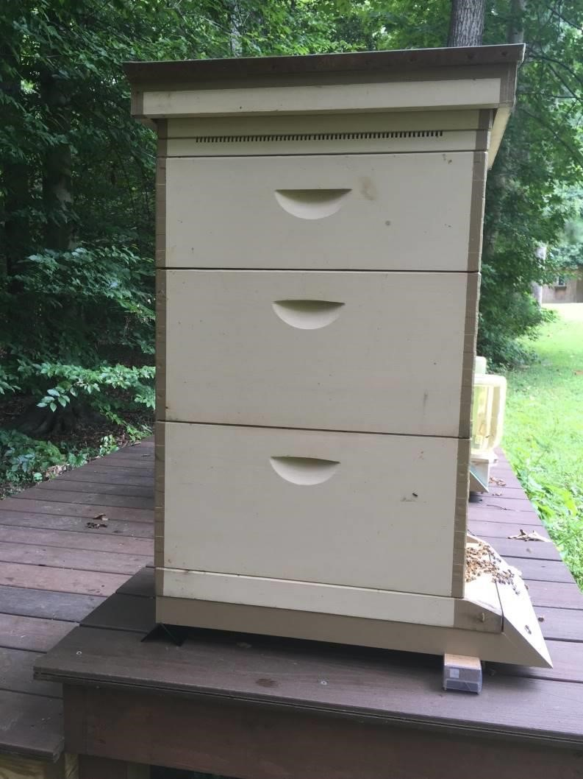

The second BroodMinder

-

TH or -T2 is placed

on top of the frames in the lower brood box.

Insert centered from the back of the hive as far as

it will go with the tab sticking out.



The first BroodMinder

-

TH (

**T**

emperature and

**H**

umidity) is placed on top of the frames in the

upper brood box. Insert centered from the back

of the hive as far as it will go

with the tab sticking

out.



Place the Hive Scale under the front of the hive

with the Device ID label facing to the right as seen

from the back. Install on the shady side of the hive.



Support the back of the hive with an auxiliary

support

### 2.2 BroodMinder-TH

All BroodMinder-TH device IDs start with 42 so they should be easy to recognize. The normal placement of the sensor is on top of the frame near the middle of the hive box of interest. This position is chosen for several reasons:

* Heat rises, therefore the sensor will feel the heat of the brood below
* The brood tends towards the middle of the hive and then surrounds the brood with pollen and honey. Placing the temperature sensor here has the best chance of sensing the brood.
* Using this standardized position allows for cross-hive comparisons across the world.

If you are in a cold climate and you overwinter in more than two boxes, then you may want to move the sensors up. This is because as the cluster moves above a sensor, that sensor tends to sense the outside temperature (since heat rises).

By placing the BroodMinder-TH sensor right below the inner cover, you will sense the heat of the entire hive. Condensation is very likely when it reaches 100% and you may want to inspect the hive and take appropriate action if necessary.

Note: Relative humidity (RH) depends both on moisture in the air and temperature. As temperature goes down, RH goes up. A good example is when RH = 100% outside dew forms. The same thing will happen in your hive.

If you move the BroodMinder-TH to the top, then you may want to move the other BroodMinder-TH to right below the top box. That way you will see as the cluster moves up past this box.

As a final note, the BroodMinder-TH is thin enough that if you want to experiment with different positions such as between the frames you can. We would love to know how this works for you and what you learn.

Whatever position you choose, you can add a tag to the data using the BroodMinder app. We’ll talk about doing that in a later chapter.

The CR2032 battery is replaceable by opening the wrapper. It should last more than a year and we recommend replacement each fall before the low temperatures of winter.

### 2.3 BroodMinder-T2

All BroodMinder -T2 device IDs start with 41 so they should be easy to recognize. The BroodMinder-T2 (**Temperature**) is a cost reduced version of the BroodMinder-TH. It will sense the hive temperature which will indicate brood rearing during the season and winter survival during the winter. Place it above where you believe most of the brood activity will be. In the winter we suggest that you put it on the frames of the upper most hive box so that it catches all of the rising heat from the cluster.

To turn on the BroodMinder-T2, press the button for 5 seconds**. The LED will flash for one minute to indicate success**. **IF YOU DON’T HOLD THE BUTTON LONG ENOUGH, YOUR T2 WILL SHUT DOWN AFTER ABOUT 10 SECONDS.** If you ever want to know if the -T2 is operating, press the button again, and the LED will flash momentarily to indicate the battery is fine and the device is operating.

To change the battery, simply cut the tape on three sides around the circuit board. Then swing the board out and replace the battery with a new CR2032. Be sure to seal the circuit board again using packing tape.

If you want to turn off the T2, you must do it with the BroodMinder app.

* Find the device and select the graph screen
* Choose device settings (the gear in the upper right corner of the screen)
* Choose Sample Rate then choose “Power Off”. This is only available for T2 devices
* Go back to the graph screen and sync the device. After it finishes, it will power off the T2.

### 2.3 BroodMinder-W

The BroodMinder-W (**W**eight) goes under the hive. There is an extensive writeup about positioning the scale in appendix A. That is a good thing to read, but if you are in a hurry, here are the basics.

The CR2032 battery is replaceable. It should last more than a year and we recommend replacement each fall before the low temperatures of winter.

*NOTE: the most typical error source is inadequate support under the scale. This can result in strange behavior as the hive flexes as it expands and contracts due to sun, rain, temperature, etc. Providing a flat support will improve results. An easy fix is to place a ¾” plywood sheet (or equivalent) under the scales.*

*ADDITIONAL NOTE: If all you want to see is honey flow, good support is not required. You will just have to ignore the daily fluctuations. You will still be able to observe the overall change in weight.*

#### 2.3.1 Place the scale in the shade

The BroodMinder-W has a temperature sensor inside which reads the local temperature. For the temperature to be accurate, it should be shaded from direct sun. This temperature is also used to compensate the weight sensors so avoiding the temperature spike created by direct sunshine will improve performance.

Being in the shade will also extend the housing life. We use UV resistant plastic, but in the direct sun even that will become degraded. If this happens, you can order a new housing on BroodMinder.com.

#### 2.3.2 Get the BroodMinder-W level

We have done our best to make installation simple. However, you need to pay attention to a couple of things.

Make sure the hive is level. This doesn’t mean “crazy level” but if your hive looks like the Leaning Tower of Pisa, then you won’t get good results. 2x4’s and shims are your friends. By using a few 2x4’s and shims creatively, you can level almost anything! We also find that screwing the 2x4’s together makes life better and more stable.

After you install the BroodMinder -W, look at the end of it. Through the plastic cover, (remember… install it *with* the plastic cover), you will see the upper wooden piece and the lower aluminum piece. Make sure that they do not touch. This will ensure that all the weight is sitting on the two little buttons on top of the aluminum base and not somewhere else.

#### 2.3.3 Typical installation, not as accurate

Using the typical installation, you will see small changes to the hive however, the absolute accuracy will not be as good. For improved accuracy, see the recommendations of the next section.

The BroodMinder-W is designed to measure ½ of the hive weight. To do this, we want you to support one side of the hive (front or back, left or right) with a 2x4 or similar [However, we recommend that you use a piece of 2” angle for the support. By orienting it so that the point of the angle iron is up, it gives a very precise pivot point. You should be able get this at your local hardware store. Aluminum is extra nice because it won’t rust. A great place to get just what you need for less than $5 each is [Speedy Metals](https://www.speedymetals.com/pc-2186-8344-2-x-2-angle-6061-t6-aluminum-extruded.aspx) (1/8" {A} x 2" {B} x 2" {C} Angle 6061-T6 Aluminum, Extruded).]

The BroodMinder-W is placed under the opposite side.

There is a nice explanation of the math and physics involved in Appendix A, however it boils down to this. **Do your best to place the support and the scale directly under the wall of the hive body.** That will give good results.

#### 2.3.4 Better installation, more accurate

A better way to install will require a few modifications to your bottom board. You will make a couple of small cuts that will be used to accommodate precise and repeatable placement of the scale and support.

First off, we recommend that you use a piece of 2” angle for the support. By orienting it so that the point of the angle iron is up, it gives a very precise pivot point. You should be able get this at your local hardware store. Aluminum is extra nice because it won’t rust. A great place to get just what you need for less than $5 each is [Speedy Metals](https://www.speedymetals.com/pc-2186-8344-2-x-2-angle-6061-t6-aluminum-extruded.aspx) (1/8" {A} x 2" {B} x 2" {C} Angle 6061-T6 Aluminum, Extruded).

Now we want to make the cuts in the bottom board. For this setup we recommend using front and back supports and not side to side. That given, you must choose whether to place the BroodMinder-W under the front of the hive, or the back of the hive.

In general, it is better to place the BroodMinder-W out of the sun. This is because the sun will heat the scale and give you a false reading of the outside temperature. Placing it in the shady side of the scale avoids this problem. It will also make the housing last longer.

Next you will cut the bottom board. For the angle iron side, you will cut a groove the width of your saw blade that the point of the angle will fit in. For the scale side, you will cut a notch 3/16” deep that ends 1” inside the center of the hive body wall. See the images below.

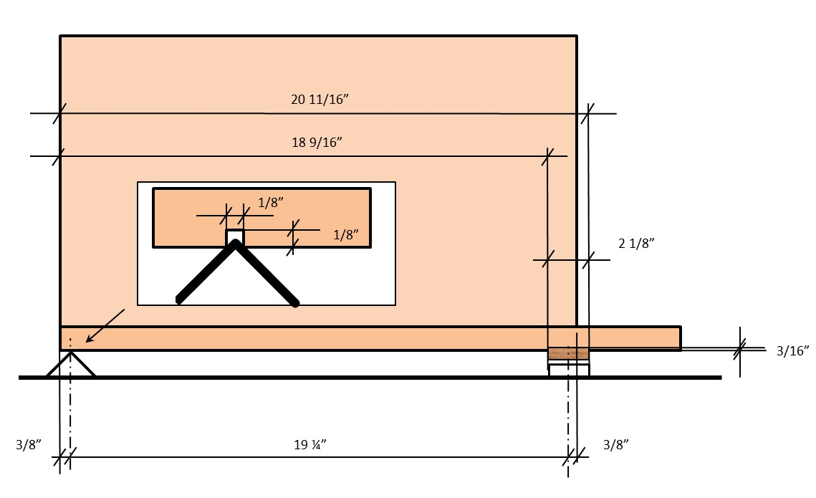

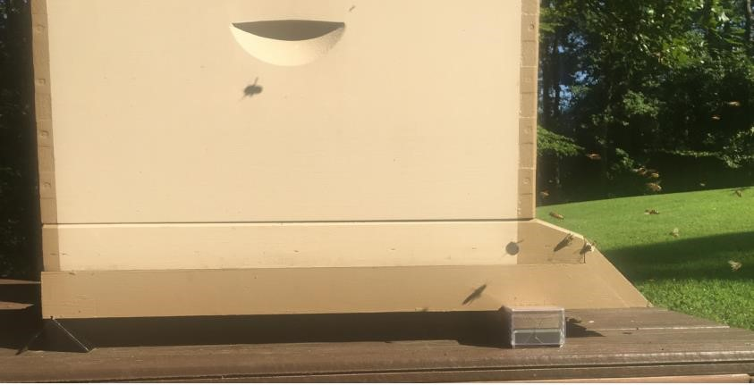

## 3 Routine Maintenance

There is not much routine maintenance that is required. Please note that if your batteries are lasting less than 6 months, something is wrong and you should contact [Support@BroodMinder.com](mailto:Support@BroodMinder.com) for replacement or refurbishment.

### 3.1 Spring

We have a video talking about spring maintenance on the support page at [mybroodminder.com/resources](https://mybroodminder.com/app/resources).

In the spring, it is a good time to clean up your devices. You can use 91% or better Isopropyl or Ethyl Alcohol, it will not harm the electronics.

You can place the wrappers in the freezer and then propolis will break off more easily.

**Ensure that the scale wrapper is not cracked, that will allow rain to harm the sensors.** You can seal any cracks with packing tape.

We also have replacement wrappers for all the devices on our website at BroodMinder.com.

### 3.1 Fall

Prior to winter, replace all of the batteries in your BroodMinders. (A good place to buy them is Amazon.com or Digikey.com. You can get them for less than $0.50 each). All of the batteries are of type CR2032.

**Ensure that the scale wrapper is not cracked, that will allow rain to harm the sensors.** You can seal any cracks with packing tape or order replacement wrappers at BroodMinder.com.

## 4 Device Software Updates

The BroodMinder-T2 and the BroodMinder-Hub devices have provision for Over-The-Air (OTA) upgrades. These are performed by the -Apiary app or the -CELL app. For more information, go to this link.

[mybroodminder.com/resources](https://mybroodminder.com/app/resources)

## 5 The BroodMinder App

### 5.1 Device compatibility

We have designed the BroodMinder App to work with most iOS (iPhone, iPad) and Android devices. We test our software on many different devices.

#### 5.1.1 Apple – iOS

The BroodMinder app will work with any Apples device that has Bluetooth Low Energy (BLE) available. It will work with iPhone model 4s or newer and with iPads 3rd generation or newer.

#### 5.1.2 Android

Android is a bit more complicated. Android introduced BLE support in Version 4.3 (Jelly Bean, July 2012). Devices before that will not work. Devices after that may work. Most new devices (2015 or newer) do work. However, there are many flavors of phone and we have found a few that give us problems. If your device does not work, then contact us at Support@BroodMinder.com.

A new feature has been added to the app in version 2.97 to increase the “advertising rate” of your BroodMinder devices. As shipped, the BroodMinder sends a message out once every five seconds that contains temperature and weight information. The General Settings page now has a Bluetooth Config button which allows you to change the advertising rate to once per second. This will speed device connection and will make data retrieval faster. It will however reduce battery life to 3-6 months.

We have also added a “Reset Android Bluetooth” under the Bluetooth Config button. This will do a system reset of the Bluetooth function. We have found that on some phones this will help re-establish communication.

There is more information at [MyBroodMinder.com/resources](https://mybroodminder.com/app/resources).

### 5.2 Installation

The BroodMinder app is available at the Apple App store, or the Android Play Store, or the Amazon Play Store, depending on your device. If you search for “BroodMinder”, (it is called BroodMinder Lite on Android) you will find it. Install it just like you would any other app.

After it is installed, start the app. The app should present you with a warm and congratulatory welcome message. You can choose to watch our Queen Bee, Laura Davis demonstrate installation, or you can dismiss the message and let the app do its thing.

The app will start scanning for BroodMinder devices in the area and will automatically fill the screen with any that it finds within the area.

If none show up:

* Make sure that the battery tab has been removed from the BroodMinder-TH and make sure that the battery is pressed into place on the BroodMinder-W
* Make sure that your phone/tablet has Bluetooth turned on
* Make sure that you are within 10-20 feet of the BroodMinder device

### 5.3 Home Screen of BroodMinder App

BroodMinder-T will display Temperature

BroodMinder-TH will display Temperature & Humidity BroodMinder-W will display Temperature & Weight

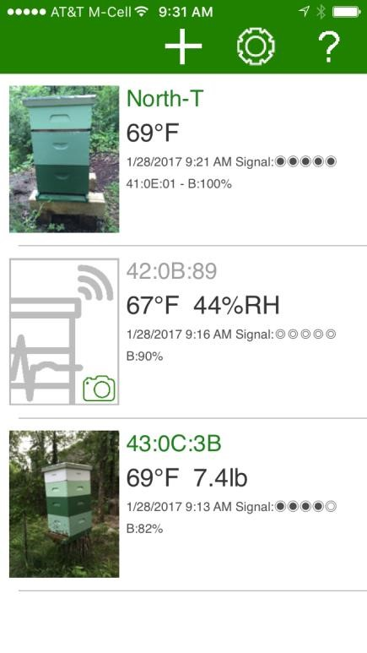

When this turns green,

a

to

close

are

you

BroodMinder

You can add your own

picture by tapping here

You can add your own

name by tapping here

Tapping here takes you to the

device details/graph screen

This icon will take you to

the global settings page.

The ? will give you a brief

help message and a link to

the video

The + sign l

ets you add any

BroodMinder to your list

stored

that

is

at

MyBroodMinder.com

This is the signal strength

from your BroodMinder. It

will

get stronger as you get

closer.

Battery level.

If you name your device,

the ID will move to here.

Swipe left to delete a

device or access the

graph

screen. (Android is a long

press)

### 5.4 Details/Graph Screen of BroodMinder App

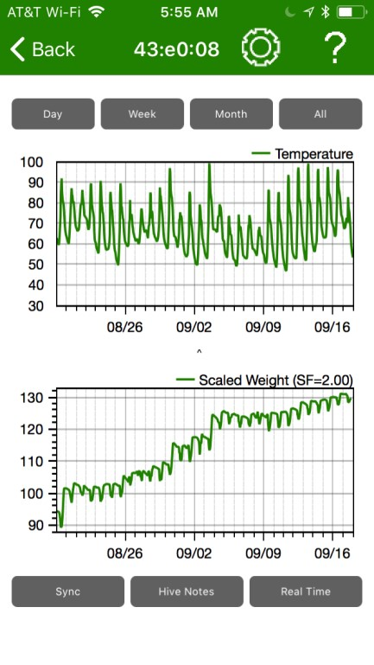

The ? will give you a brief

help message and a link to

the video

This icon will take you to

the device settings page.

The < sign will take you

back to the

home screen.

This row of buttons sets

the overall time scale of

the graphs

You can pinch & zoom to

adjus

t the graph position

retrieve

will

Sync

the

Hour

-

by

-

Hour (HbH) data

from your BroodMinder.

You must be within 10

-

20

feet of the BroodMinder.

Press this button and your

data will be stored to the

cloud

at

beekeeping.io.

The first time it will create

and

user

a

name

password. Then it will

help you cre

ate an apiary

& hive. These are stored so

that the second time it is

very quick.

the

at

data

If

Beekeeping.io is newer or

the device is owned by

someone else, then it will

bring that data into the

BroodMinder app.

Real Time will display the

BroodMinder values once

every 5 seconds.

to add

Notes allows you

standardized notes to the

data.

### 5.5 General Setting Page

at the expense of battery

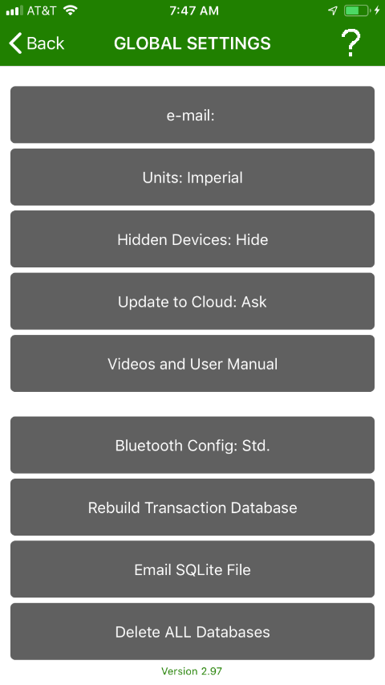

The ? will give you a brief

help message and a link to

the video

display

to

Change

the

metric!

This e

-

mail address will be

used for default if you e

-

mail data. It will also be

for

your

used

Beekeeping.io login.

The < sign will take you

back to the home screen.

If you choose to hide a

device

in

the

device

setting menu, this will

make it appear again.

rebuild

the

You

can

transaction database from

data in the Hour

-

by

-

Hour

d

atabase.

old

The

database will be e

-

mail

before creating the new

one.

Change the message rate

of your BroodMinder.

You can speed up connection

You can e

-

mail the entire

database to yourself for

for

backup.

See

below

restoration instructions.

will

delete

every

This

database

BroodMinder

on

your

stored

phone/tablet.

Look at this document with

your phone/tablet.

choose

can

You

Always/Ask/Never update

to the cloud after Sync.

### 5.6 Device Setting Page

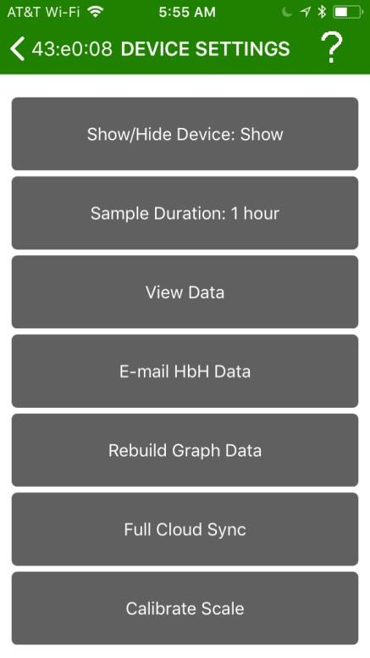

The ? will give you a brief

help message and a link to

the video

Choose the sample time

for your BroodMinder. It

defaults to one hour. Note

that reducing the sample

time will shorten battery

life.

The < sign will take you

back to the home screen.

You can make this device

disappear from the home

screen list. You can see it

again it with

a setting in

Global Settings.

These are scale factors

used for BroodMinder

-

W.

The

y are for service use

only.

E

-

mail the HbH (Hour

-

by

-

data

Hour)

as

a

CSV

(

comma separated

value)

attachment.

View the HbH (hour by

hour) data as text.

This function will remove

redundant data and also

eliminate any obviously

erroneous values. Use it if

your graphs are taking a

very long time to load

there

because

may

be

excess data stored.

This function will retrieve

all of the device data and

it

the

compare

with

BroodMinder app data. If

there are missing samples

on

MyBroodMinder.com,

the app will fill in the gaps.

### 5.8 Real Time Mode

If you would like to see “Live” data, you can use the “Real Time” button on the Graph screen. Pressing this button will change the sampling rate to 5 seconds and then show a display of values in the lower section of the screen.

B: Battery level

T: Temperature (currently only F)

H: Relative Humidity in %

L/R: Balance between left and right sensors. Adds to 100% (-W scale only)

W: Total weight (currently only pounds) (-W scale only)

Delta: Change in weight from when Real-time started. (-W scale only)

This data will also be saved in the log file.

Pressing the “Real Time” button again will leave this mode and set the sampling rate back to 60 minutes.

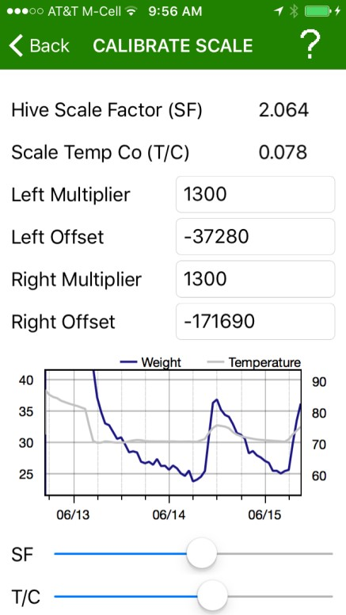

**5.7**

**Setting the BroodMinder**

**-**

**W scale factor**

These two controls will adjust the BroodMinder

-

W

scale

factor

(

SF)

and

temperature

compensation (T/C). You will see the graph

update as the sliders change.

The Left/Right Multiplier & Offset values are for

reference only.

For advice on how to adjust these

, keep reading

below.

By default, the BroodMinder-W scale factor is set to 2.0. This means that any weight the BroodMinder-W sees is doubled to reflect the full weight of the hive. From looking at the physics of the situation (see appendix below) we know that this is an approximation and not totally accurate. In most cases, it is close enough since small changes will still be seen and a 5-10% error in total weight is not important.

A more accurate total weight display can be obtained by adjusting the scale factor to account for the hive specific situation.

Go to the Graph Screen of the scale and press the real time button. In a few seconds, the app will begin to display the scale reading once every 5 seconds at the very bottom of the screen. You can also see the % load on each load cell.

Now add a known weight of 10-20 pounds to the top center of the hive. You should see this weight change in the app readout. Then you can adjust the scale factor to exactly match the weight change.

Example:

Weight Delta Weight Scale Factor Notes

121.2 0.0 2.0 Start of Real Time

132.2 11.0 2.0 We added the weight

Now we go change the scale factor

129.5 10.0 1.82 Now the calibration is closer

117.0 0 1.82 After the weight is removed,

we see the new more accurate hive weight

### 5.8 Setting the BroodMinder-W temperature compensation

The sensors used in the BroodMinder-W are very high quality and exhibit little temperature effect. However, there is still variation from scale to scale and therefore we have provided a means to improve the accuracy through the adjustment of the scale temperature compensation – “Scale TempCo”.

To adjust the TempCo, you should pick a portion of your weight graph in which you know there is little weight change due to bee activity. A cloudy day is a good time because we know that they are not foraging. There should also be a good outdoor temperature change of at least 20 degrees F in less than a day.

As you make small changes to the TempCo value, you will see the weight graph settle out to a uniform weight as one would expect.

If you see weight spikes even after adjusting, then possibly it is due to the scale being in the sun. The sun can heat of the scale quite quickly and dramatically. This makes it very difficult for the TempCo to be effective.

### 5.9 Tagging Graphs



Pressing the

Hive Notes

button lets you add text to any point in time

on the graph. This is useful to expl

ain abrupt changes in the data or

whenever you do a hive inspection.

This

button will bring up a sub

-

menu with eight groups of possible

occurrences

or actions. Select the one most appropriate for your

situation and choose the corresponding tag. Use “Custo

m” if the list

does not cover your situation. The

selections

in the app will be

updated as time goes on to best reflect the tags most used.

The time shown in the top half of the screen is the current time if

the graphs have not been moved by pinching or sw

iping before the

“Tag Graph” button has been pressed. It can be adjusted by clicking

on it.

When

noting

a past event, it is useful to move the chart and line up

the

time of the event with the “Note

Time Indicator” and then press

Hive Notes

. In this case,

the

note

time in the

notes

window is the

time at the “

Notes

Time Indicator” and not the current time.

Hive Notes allows you to

add standard notes to the

data.

Note Time Indicator

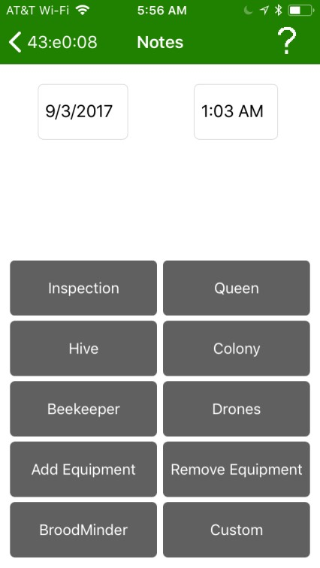

Of particular interest is the “Inspection” button. This button will

walk you through a 6 easy to answer questions about the state of the hive. The list was shared with us by Dick Rogers and we think it is a quick and effective way to document the hive.

## 6 BroodMinder-APIARY App

Introduced in 2018, the BroodMinder-APIARY app is our most powerful app. It will read and upload every BroodMinder device in your apiary directly to MyBroodMinder with a single keypress. It can also be used to automatically send your live data to MyBroodMinder.com every 10 minutes.

Once the data is transferred, review of data and keeping hive notes can be done directly on MyBroodMinder.com. We recommend this because of its ease of use.

Please note that this app only stores your hour by hour data in the cloud and does not keep a copy on your phone and/or tablet.

New features have been added in 2019.

* Remote uploading – The apiary app now works with or without internet connectivity.
* Hub mode – You can use any internet connected iOS or Android device to send data every 10 minutes from your apiary
* CELL wakeup – The BroodMinder-CELL device can be taken out of deep sleep.

While saving you lots of time in collecting data from your devices, this app comes with a small caveat. You must have MyBroodMinder Premium to upload all devices automatically or use hub mode. To allow you to test out its features, you can use the app free of charge for 30 days after creating your MyBroodMinder account.

We charge for this in order to provide a small income to our BroodMinder software team. They work very hard to create and maintain the MyBroodMinder and BeeCounted.org websites. Usage of the standard BroodMinder app will always remain free. Likewise, uploading to MyBroodMinder from the standard app will always remain free.

You can still use the Apiary App indefinitely to upload single devices. This is useful because it is a newer software package and the upload process is more streamlined than the original app.

Usage of the app is super simple.

1. Go to MyBroodMinder.com and create an account (this is free).
2. Download BroodMinder-Apiary from your app store.
3. Start the app and press the gear icon and enter your MyBroodMinder credentials.
4. Return to the list screen and in a few seconds it will automatically find every BroodMinder device in the area and display them on the screen.
5. After the BroodMinder IDs turn green, press the cloud icon  in the upper right of the screen to begin upload to MyBroodMinder.
6. Now the app will show you a upload progress screen. The top line is status while harvesting the BroodMinder data. The lower line shows the transfer to MyBroodMinder status. 6) After all of the devices have uploaded you will see a transfer complete message.

After the transfer is complete, the data will show up in MyBroodMinder. If you have already set up your devices, all you do is look. If these are new devices, you will need to find them in your MyBroodMinder “Device Inventory” and assign them to an apiary and to a hive. See the next section on MyBroodMinder.com for more on that.

Upload to MyBroodMinder

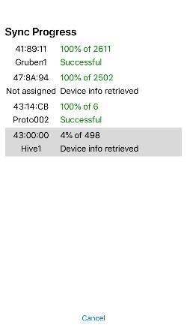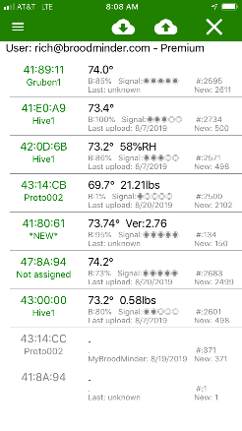

Clear list (does not delete data)

Retrieve devices before remote upload

BroodMinder ID /Hive

BroodMinder status

MyBroodMinder status

Settings menu

HbH data retrieval

progress

MyBroodMinder

sync progress

‘Cancel’ will halt

sync for one device

or all devices

List Screen Progress Screen

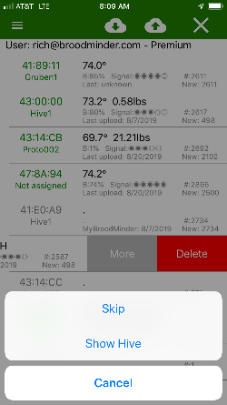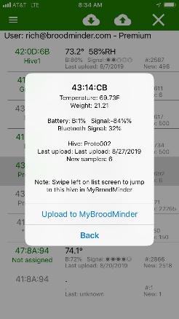

Pressing the list text will bring up the device status in detail.

You can also use this screen to select a single device for upload.

Pull left (long press on Android) for options.

Skip – do not include device in upload.

Show Hive – go to this hive at MyBroodMinder.com

Delete – remove from list, will not delete data.

Details Screen Options Screen

See below for details

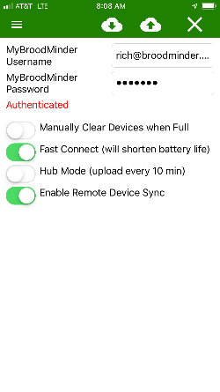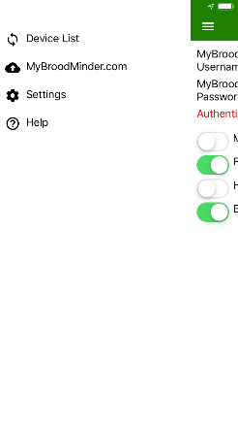

Back to device list

Go to MyBroodMinder.com, you can use this to create a login. It will start up your web browser.

Quick Help

Settings menu

MyBroodMinder.com

credentials

Settings

MANUALLY CLEAR DEVICES WHEN FULL – If your BroodMinder device has been running for a long time (over 9 months), the memory can get full. When it does, the apiary app will automatically reset it so that it can store more. If you want manual control, flip this switch.

FAST CONNECT – This will speed up connection time by making the ‘advertising rate’ faster. This means the BroodMinder will send out a signal every one second instead of every 5 seconds. The downside is that it will also shorten battery life. You might want to set this fast in the summer and slow in the winter.

HUB MODE – See below.

ENABLE REMOTE DEVICE SYNC – You can retrieve data even when there is no internet connection or cell coverage in your apiary.

1. Before going to the apiary – go to the device list and press the cloud with the down arrow 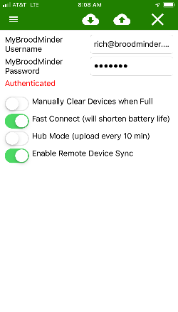. This will load the list with all of you devices and the last time data was retrieved. (If you don’t do this, all of the data will be retrieved from your BroodMinder. This could be a full year of data!)
2. When in the field, sync your devices like normal. They will fail upload since you don’t have internet, but that is OK.
3. When your return to civilization, restart the app and it will suggest that you upload to the cloud now. Do this and MyBroodMinder.com will get updated.

**HUB MODE**

Hub mode lets you use and old phone or tablet to automatically send your BroodMinder data to MyBroodMinder once every 10 minutes. This way you can see how your bees are doing 24/7 from anywhere in the world.

Just enable hub mode and return to the list screen.

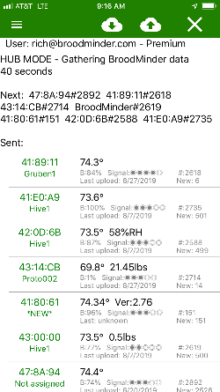

MyBroodMinder.com account

Hub mode status

Devices sent already

Devices found

Device/samples number to be sent next

## 7 MyBroodMinder.com Cloud Storage

The true power of the BroodMinder movement is in the data from thousands of hives stored for public consumption at MyBroodMinder.com.

We have done our best to make it as simple as possible for you to transfer the data there. **From the BroodMinder App, you only need to push the Sync button and answer a few questions.** The app will create a new MyBroodMinder account for you and everything needed to get going.After that the data will be transferred. *You do not need to create a MyBroodMinder account before pushing data.*

Once the data is on MyBroodMinder.com you can see it and combine the data from the sensors into one easy to read graph for each hive.

With any web browser, go to MyBroodMinder.com. You will need to enter the same username (e-mail) and password. After that you will see a menu similar to the image below.

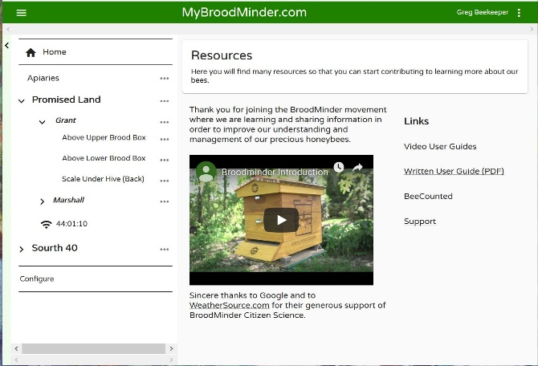

Show/hide the side bar

The side bar allows you to navigate to all of your hives and devices. Click on the > to reveal hives and devices.

… (three dots) to the right let you do quick changes.

Our jazzy intro video

Lots of helpful resources 😊

Use configure to view BroodMinder inventory and move devices between hives.

You will see a graph like this that combines all of the sensors in a hive into one report.

These are the devices assigned to this hive that are being displayed.

Use this bar to change the graph range. You can also drag with your mouse left button pressed over the graph to zoom in on a region.

Add existing device will find a device that was uploaded already that is new.

Add New Device will create a new device that has not been uploaded yet.

Honeybee Productivity is the weight change created by the bees, not the beekeeper. Any time there is a change in one hour > 10 pounds, it is left off the graph.

You can add lots of notes here and they will show up on the graphs.

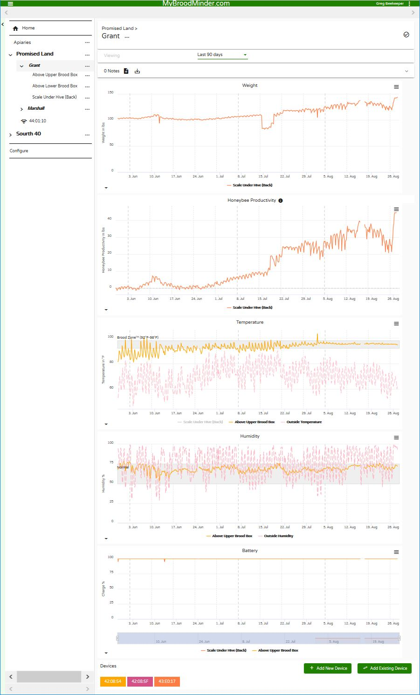

This is the hive being displayed.

Use the configuration menu to set everything about your MyBroodMinder.com universe.

These are all of you devices.

Location history lets you move them.

With edit you can change the name.

Download Devices will create a text (CSV) file with all of the devices and locations in it.

Use the filter to see only certain devices.

Add or delete hives here.

In this menu you can add and delete apiaries. If you get the zip code wrong, ask [support@broodminder.com](mailto:support@broodminder.com) to change it.

Choose metric/imperial.Interpolate graphs will fill in missing data. This can be confusing but some people like it better.

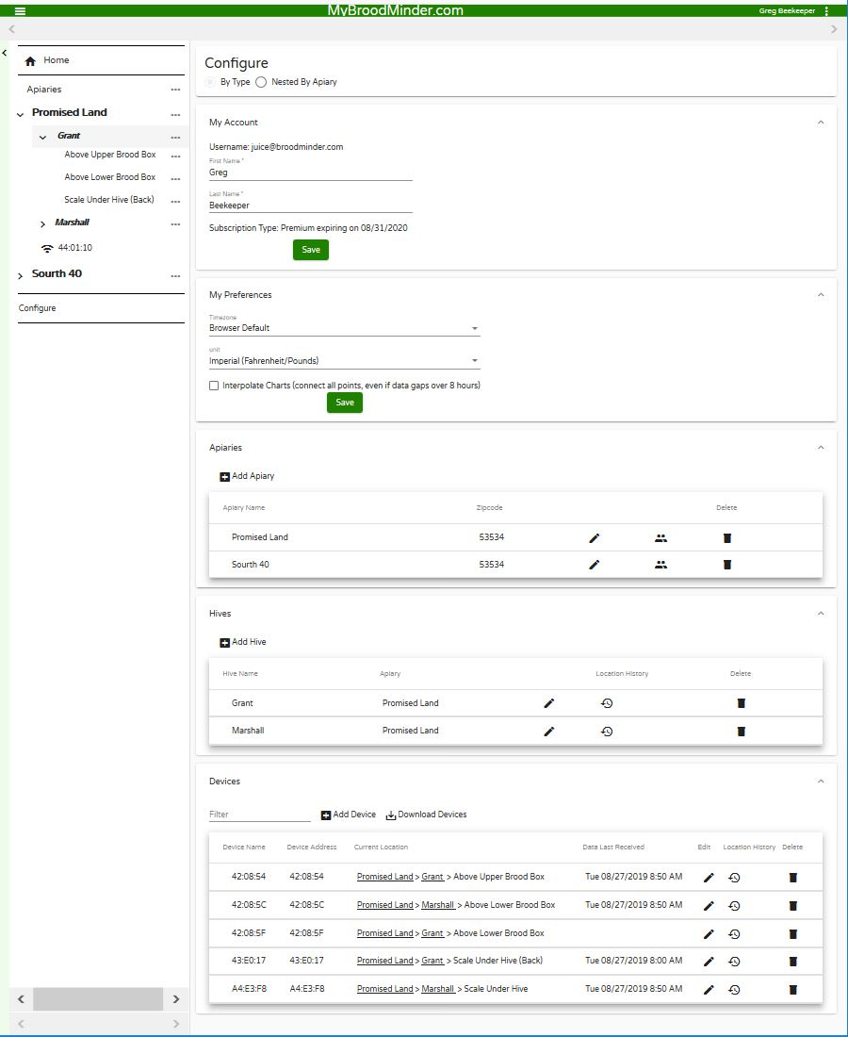

Put your real name here. You can also renew your premium subscription here.

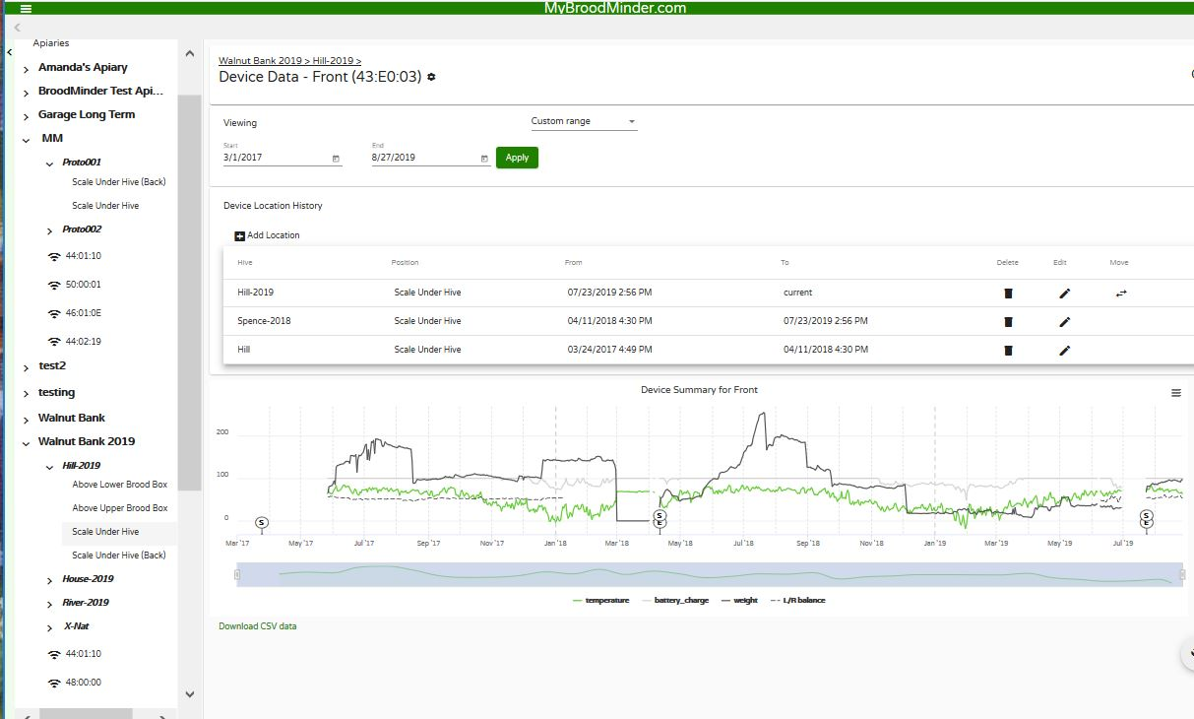

When you navigate to the device level, you will see the location history.

In this example, you can see 43:E0:03 BroodMinder-W started in the hill hive in 2017 and then moved to two different hives. On the graph, you will notice the ‘S’ and ‘E’ which stand for start and end times in a hive.

You can change these dates with the edit function.

If you are moving it to a new/different hive, use the MOVE function.

**8 Databases!**

Everybody loves databases! We know we do!

In the BroodMinder App there are two databases.

* Transaction database – This database holds all of the interactions between you the operator and your BroodMinders. Each time you go to retrieve data it will keep a record of it.
* Hour-by-Hour (HbH) database – This one holds all of the HbH data that your retrieve from your device using the SYNC button.

### 8.1 Database operations

There are several things that you can do with the database using the BroodMinder App. Here is a quick list. We will follow-up with details.

Some of these operations are tricky! If you are not confident of doing them, send us a note at Support@BroodMinder.com. Mike or Theo will be happy to help.

* Send CSV (Comma Separated Variable) text file to yourself (or others) o Transaction Database o HbH database
* Send SQLite file to yourself (or others) – The SQLite file is the main database that is used by the App. This holds all of the data in one file that can be read and modified by a compatible program.
* Import HbH CSV file from e-mail – You can send a file to yourself, modify it, and then read it back in.
* Import SQLite file from e-mail – You can send the SQLite file to yourself, and then read it into a different device.
* Rebuild database o Transaction database – When you rebuild the transaction database, it deletes it and then creates a new one by reading the newest data point from each device in the HbH database.

o Rebuild HbH database – When you rebuild the HbH database, it reads the

MyBroodMinder.com data and adds it to the current HbH data on the device. Then it deletes redundant points and gets rid of clearly anomalous values.

* Delete database o Delete device – you can delete data from a single device. o Delete All – you can delete the entire database and start over.

### 8.2 Send CSV (Comma Separated Value) Text File

The easiest way to get to your data is to e-mail a CSV file to yourself. You can either send the Transaction database, which contains all of the devices and all of the observed data when you visit the hive (but not the HbH data). Or you can send the HbH data which is all of the data from a specific device. You will find these buttons in the Global Settings and Device Settings menu.

When you press either button, you should see the device e-mail app come up and it will generate an email with a file attachement. It will send it to the e-mail address that you gave in the global settings screen, or you can add any other e-mail address that you would like.

Here are definitions of the file contents.

#### 8.2.1 Transaction Database Fields

**UUID** – This is the device ID that is written on the circuit board

**Model** – The device Model and firmware version. E.g. 42-2v56, Model 42, Version 2.56 (Model

41=BroodMinder-T, Model 42=BroodMinder-TH, Model 43=BroodMinder-W, Model 44= BroodMinderCELL)

**TimeStamp** – Timestamp of transaction in text readable format

**Unix_Time** – Timestamp of transaction in UNIX format

**Sample** – Sample number of data from BroodMinder

**Signal** – Bluetooth signal strength from BroodMinder

**Battery** – Battery voltage (0-100%)

**Metric** – 0 for Imperial, 1 for Metric

**Temperature** – Temperature from BroodMinder

**Humidity** – Relative Humidity from BroodMinder (0-100%)

**Weight** – Total weight from BroodMinder including scale factor

**Weight Scale Factor** – Scale factor for Scaled_Weight

**Hidden** – TRUE if hidden flag is set which hides device from home screen

**Name** – The name that you gave the BroodMinder device

**Notes** – Various notes

**SamplePeriod** – The sample period of the BroodMinder in seconds, defaults to 3600

(Note: If you look directly at the SQLite database, you will find time in “ticks”. To convert to excel time you can use the equation =(A1*POWER(10, -7) / 60 / 60 / 24)-693593 where A1 contains ticks)

#### 8.2.2 HbH Database Fields

**App Ver** – This is the version of the BroodMinder App that wrote this record

**UUID** – This is the device ID that is written on the circuit board

**Model** – The device Model and firmware version. E.g. 42-2v56, Model 42, Version 2.56 (Model

41=BroodMinder-T, Model 42=BroodMinder-TH, Model 43=BroodMinder-W, Model 44= BroodMinderCELL)

**Record_Type** – Type of data in record *Logged_Data* or *Sample_Period* or *Time_Stamp* or *Note*

**DownloadTimeStamp** – UNIX time that the data was SYNCed

**TimeStamp** – Timestamp of sample in text readable format

**Local_Excel_Time** –Timestamp of sample in Excel readable format

**Unix_Time** – Timestamp of sample in UNIX format

**Logging_Period** – BroodMinder logging period in seconds

**Sample** – Sample number of data from BroodMinder

**Metric** – 0 for Imperial, 1 for Metric **Battery** – Battery voltage (0-100%)

**Temperature** – Temperature from BroodMinder

**Humidity** – Relative Humidity from BroodMinder (0-100%)

**Scaled_Weight** - Total weight from BroodMinder including scale factor

**Weight Scale Factor** – Scale factor for Scaled_Weight

**Weight** – Non-scaled weight(Weight = WeightL + WeightR)

**WeightL** – Non-scaled weight from left sensor

(WeightL = ((WeightLRaw * MULT) + OFFS) / 100,000 / 100 MULT & OFFS are written on the scale label

**WeightLRaw** – Raw 24-bit ADC value from left sensor

**WeightR** – Non-scaled weight from right sensor

WeightR = ((WeightRRaw * MULT) + OFFS) / 100,000 / 100

MULT & OFFS are written on the scale label

**WeightRRaw** – Raw 24-bit ADC value from right sensor

**Hive_Name** – The name that you gave the hive or the default UUID name

**Notes** – Various kinds of notes including tags

### 8.3 Send SQLite file

The SQLFile sends just like the CSV files do. The big difference is that before it is sent, it is zipped (compressed). This file contains both the Transaction database and the HbH database of all of the devices.

If you want to look at the contents, after you decompress the .gz file (you can use 7-zip for this) you need to add .DB3 to the end of the filename. If you are going to transfer the file to another device running the BroodMinder App, you don’t need to do anything.

There are a couple of nice (free) readers out there. “DB Brower for SQLite” (<http://sqlitebrowser.org/>) for PC and “SQLPro for SQLite Read-Only” ([http://sqlpro-sqlite-read-only-sql-and-coredatahttp://sqlpro-sqlite-read-only-sql-and-coredata-managereditor.softwar.io/managereditor.softwar.io/](http://sqlpro-sqlite-read-only-sql-and-coredata-managereditor.softwar.io/) ) for Mac are two examples.

The great use of this file is that you can transfer all of your information to a new device! See the next section.

### 8.4 Import HbH CSV or SQLite file

So once you have e-mail the SQLite file to yourself, how do you get it back into the app. This can be to your normal device, or to a new one.

When you install the BroodMinder App, it adds the ability to import CSV & SQLite files. The import process is similar, but what happens when it imports is different. First let’s talk about the import process.

Importing into the BroodMinder App is pretty easy. The process is slightly different between iOS and Android.

iOS

* Bring up your email reader and select the e-mail with the CSV or SQLite file.
* When you tap and hold the icon for the file attachment, a list of apps should pop up. On that list you should see “Import with BroodMinder” along with the BroodMinder Logo.
* Press the icon and this will bring up the BroodMinder App with further instructions.

Android

* Bring up your email reader and select the e-mail with the CSV or SQLite file.
* When you tap the file attachment you will download the file. It will retrieve the CSV file and place it in your Downloads folder.
* Next go to My Files and tap the file that you just downloaded.
* Now you may be asked what app to use, choose BroodMinder and this will bring up the BroodMinder App with further instructions.

### 8.5 Import HbH CSV

You can only import the HbH data. You cannot import the Transaction Database.

Note that the filename must be “BroodMinderHbHData.CSV”.

Before importing the CSV file, you can edit/delete values in the file that you e-mailed to yourself. This means that you can clean up data that should not be there. For instance if you started the BroodMinder in your house and then moved it to the hive later.

WARNING: When you import a CSV file, the app expects to see the standard columns that exist in the exported CSV file. This means that while you can change the values and delete lines, you should not change the columns.

Also note that import uses the UNIX_TIMESTAMP as the actual sample time. Other timestamps in the file

are only added for your convenience. They are not used by the BroodMinder App or by MyBroodMinder.com.

Note that the app will ask you if you want to ADD the data to the existing data or REPLACE the entire HbH data record for this device. Note that if you keep adding, you may get multiple copies of the data. You can clean this up with a HbH Database Rebuild.

### 8.6 Import SQLite File

When you import a SQLIte file, it replaces the entire database in your device. The one thing it does not do is replace the pictures. You will have to do that manually.

Note that the filename must be “BroodMinder.gz”.

WARNING: Be sure to export the SQLite database in your device before replacing it with a new one. The old one will be DESTROYED.

The powerful aspect of being able to import a SQLite file is that if you have a problem, you can e-mail the SQLite file to us. Then we can fix the problem and send a new, repaired database back to you. Cool huh?

### 8.7 Rebuild Database

If you would like to clean up your database, you can try rebuilding it. Don’t do this unless you understand what you are doing. Feel free to send questions to Support@BroodMinder.com.

**Rebuilding the Transaction Database** – When you rebuild the transaction database, it is rebuilt from any HbH data that is on your device. The old transaction database is first e-mailed to you, and then deleted. Then the App goes through all of the HbH data and creates an entry for every unique device it finds. Finally, it takes the newest data point for each device and adds it to the transaction database.

**Rebuilding the HbH Database** – The rebuild of the transaction database is a bit different. When you start the rebuild, you will be asked if you want to retrieve the MyBroodMinder.com data. If you do, it will be merged with the data already on your device. Once it is merged, the program will look through the data for redundant data points and remove them. It will also look for crazy values (for instance negative weight) and remove them. Once it has done this, it will replace the HbH data on the device with the new data.

Note that if you want to update MyBroodMinder.com with this data, you must first go to the

MyBroodMinder.com website and delete the device. You can do this in the settings menu on the website for this device. Then you can press MyBroodMinder.com on the BroodMinder App and send the new data up.

WARNING: Only do this if you fully understand the process. Send a note to Support@BroodMinder.com if you need help.

### 8.8 Delete database

You can delete the databases. This should be pretty self-explanatory. Be careful, they really are gone once you do this. There is no “UNDO”!

## 9 BroodMinder-WIFI & BroodMinder-CELL

BroodMinder-WIFI/CELL is an optional component which sits in your apiary and relays data from your BroodMinders directly to Beekeeping.io via a WIFI or CELL connection. We have designed the BroodMinder-WIFI/CELL to automatically begin working when power is turned on.

### For best results, watch the installation video at [BroodMinder.com/pages/videos](https://broodminder.com/pages/videos)



CELL or WIFI Module (each will be slightly different)

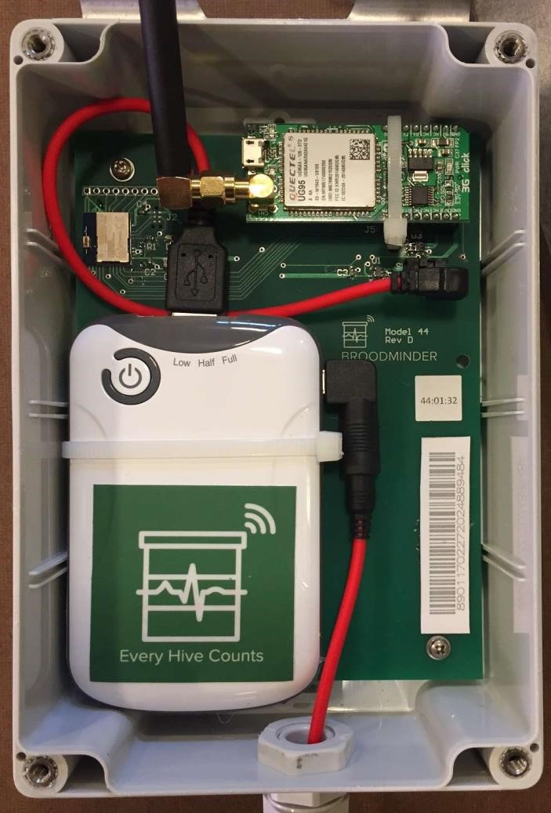

Bluetooth Module



Master Power Switch (On is to the right)



Solar Power Switch



BroodMinder

-

WIFI/CELL ID

number



Cellular ID number (Cell only)

-



#### 9.1 Quick Start Instructions

. IMPORTANT: Sync all devices & **post to Beekeeping.io** before starting your BroodMinder-WIFI/CELL

. Place the BroodMinder-WIFI/CELL in the apiary with the solar panel towards the sun

. Get the BroodMinder-CELL app (even if it is a WIFI/CELL unit)

. Start the app, your BroodMinder-WIFI/CELL should show up on the list.

. Press exit deep sleep

. WIFI/CELL only – Enter your WIFI/CELL network name and password (matching capitalization is important)

. DONE! - Data should start showing up in beekeeping.io in about an hour.

#### 9.2 Installation

You can install your BroodMinder-WIFI/CELL in many different configurations depending on circumstances. The bracket on the back of the electronics enclosure may be flipped as shown in some of the examples.

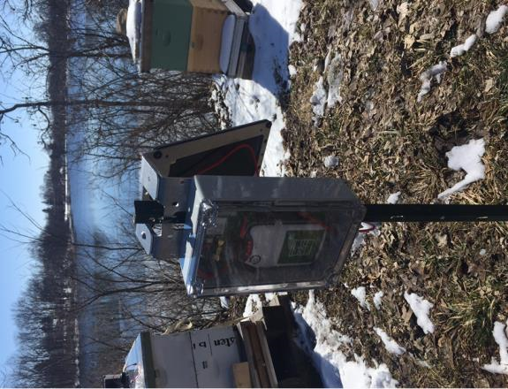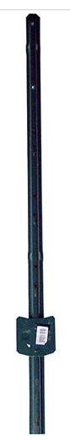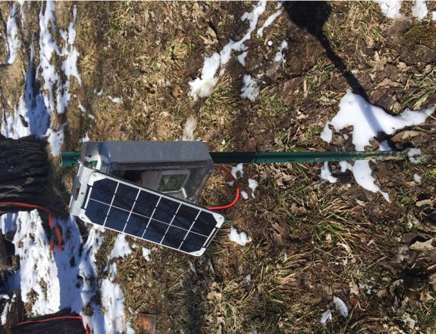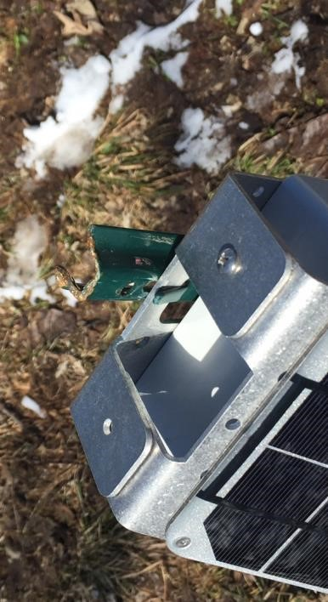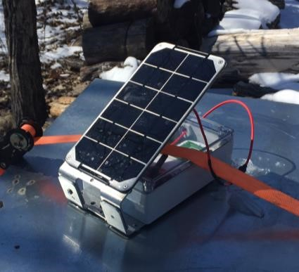

Here are a few installation considerations

* The solar panel will fully charge the battery with about 4 hours of good, direct sunlight.
* The battery should last 3-4 days with no good sunlight
* Wireless reception is hampered by trees. Mounting on a tree may be problematic if your signal is marginal.
* In extreme cases we can suggest a more sensitive antenna (Cellular only). Contact us at Support@BroodMinder.com.
* Tie wraps or pipe clamps may be used to secure the system
* A small 3’ post like available at major hardware stores works well. They have tabs that can be slightly bent to allow the BroodMinder-WIFI/CELL to be inserted. Then, a tie wrap at the bottom secures the unit.

#### 9.3 Solar Battery Always-On Mode

We ship BroodMinder-WIFI/CELL with the battery in **Always-On** mode. Under normal conditions, you will not need to open the electronics enclosure.

The solar battery is a Voltaic V15 and features two power modes.

* In **Always-on** mode, the V15 power never turns off
* In **Auto-off** mode, the V15 power automatically turns off after about 20 minutes

It is important to have the V15 in **Always-on** mode so that the BroodMinder-WIFI/CELL continues to work 24 hour per day.

Let us repeat: We ship BroodMinder-WIFI/CELL with the battery in **Always-On** mode. If you never hold the V15 (solar) power button for more than 5 seconds, you do not need to change anything.

If you do hold the V15 power button for > 6 seconds, it will change the mode. It alternates from **Alwayson** to Auto-off and back and it is a little tricky to figure out which mode it is in.

To tell the difference, watch the V15 lights AFTER the 3 flashes described below.

* Block the solar panel to make the lights less confusing
* Press and hold the power button
* After 6 seconds, the LEDs on the V15 will flash 3 times
* If the light stays on for a few more seconds, it is in **Always-on** mode. This is good!
* Release the power button

If after the 3 flashes, the V15 lights turn off, it is in Auto-off mode. This is not good. Try again and it should be correct this time.

You can find more information at <https://www.voltaicsystems.com/always-on/>

#### 9.4 WIFI/CELL Indicator Lights

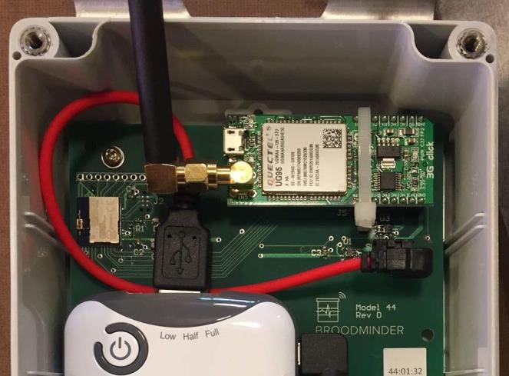

Cellular modem main power indicator (green)



Cellular Status (opera

ting) (yellow)



Cell network (red)



Voltaic V15 LEDs (4 red)

•

LEDs will flash when charging

•

If you press 1/0 button, they will

display

s

tate of charge (1

-

4)



BroodMinder

-

CELL Status LED

–

After power on it does this…

1)

Blink for each BroodMinder sensor

that it finds

2)

On while initializing cell modem, and then blink value of signal strength

a.

0

-

, 0 = poor, 31 = good, 99 = no connection

31

b.

Signal < 5 connection too poor to operate reliably

#### 7.5 BroodMinder-WIFI/CELL App

The BroodMinder-WIFI/CELL App allows you to closely watch how things are going. Some of the things that you can monitor include:

* Deep Sleep Mode – see below.
* Current status of BroodMinder-WIFI/CELL (Initializing, time until next data transfer, connecting to WIFI, sending data)
* Number of BroodMinders found in the apiary
* WIFIular signal strength
* Lots of diagnostic features

We won’t go into a lot of detail in the manual because there is not much to adjust with the app. In fact, the only things that you can adjust is when and how often data is transferred to beekeeping.io. The rest of the app is to aid our support personnel in diagnosing problems.

When you receive your BroodMinder-WIFI/CELL, it should be in Deep Sleep mode in order to conserve the battery during shipment. You will need the BroodMinder-CELL app to wake it up.

By default, the BroodMinder-WIFI/CELL will transfer data hourly.

#### 9.6 WIFI/CELL App Home Screen

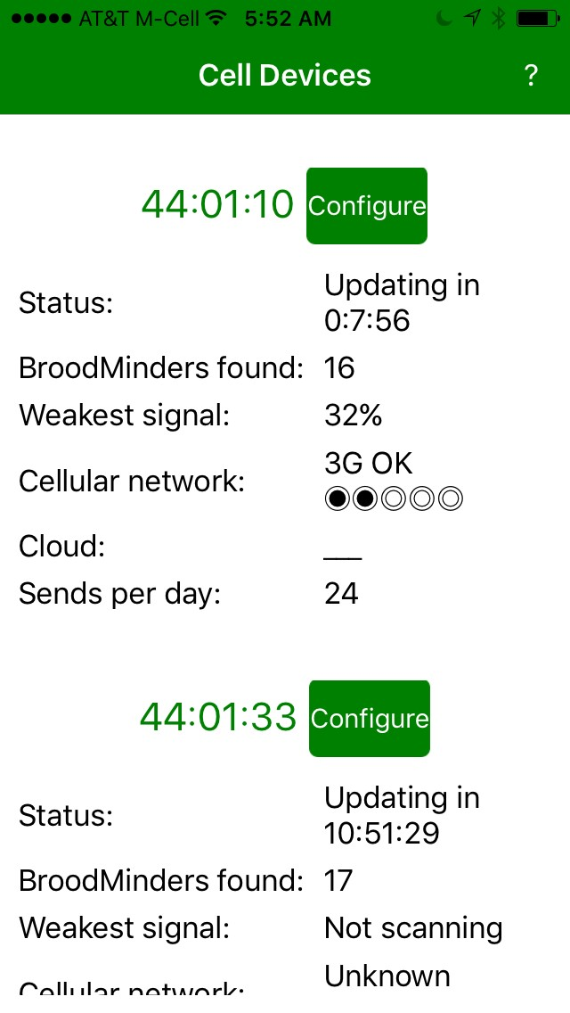

Press this button for more detailed

information



Status tells what

the BroodMinder

-

CELL is thinking about right now



The number of BroodMinders within

range of the BroodMinder

-

CELL



BroodMinder

signal

The

weakest

received. This helps you to position

the BroodMinder

-

CELL appropriately



Cellular network found and signal

strength



The number of times per day that

Beekeeping.io will be updated

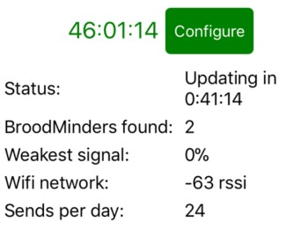

Wifi example

Note: if you left swipe on the screen you can delete unused BroodMinder-WIFI/CELL devices.

#### 9.7 WIFI/CELL App Configure Screen

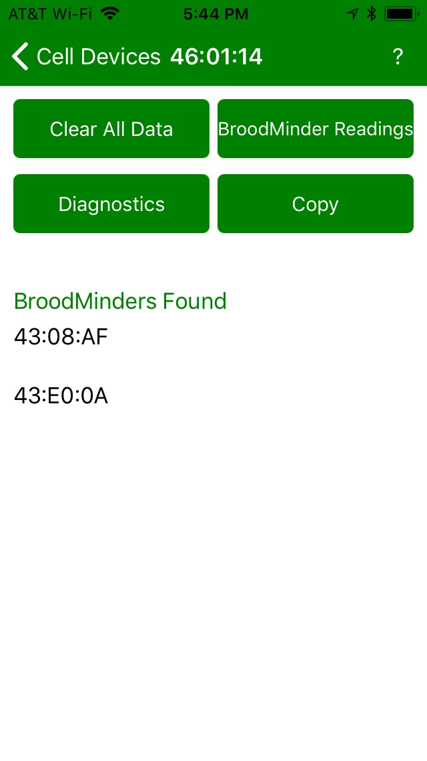

Quick Help



These are the BroodMinders that have

been detected by BroodMinder

-

CELL



Cell/Wifi Modem & BLE diagnostics



This will show all of the readings that

be

sent

during

the

next

will

connection



This clear out all of the data in the

BroodMinde

r

-

CELL.

Copy this screen. You can paste in

email.

#### 9.8 WIFI/CELL App Diagnostics Screen

**Firmware Version –** This shows the version of firmware in the BroodMinder. (e.g. 0.17)

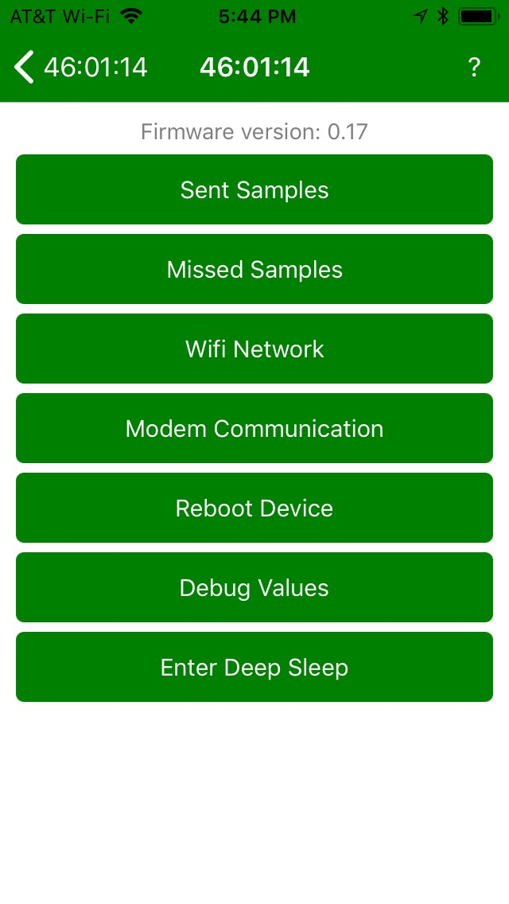

**Sent Samples –** The number of samples sent to beekeeping.io

**Missed Samples –** The number of missed samples as indicated by missing sequence numbers.

**WIFI/CELL Network –** WIFI/CELL diagnostics, see next page

**Modem Communication –** Watch the communications to the Wifi/Cell modem.

**Reboot Device –** This will restart the BroodMinderWIFI/CELL and purge it of all stored data.

**Debug Values –** These are Amanda’s secret debug values.

**Enter Deep Sleep –** When we ship the device, we put the -WIFI/CELL in deep sleep to suspend all WIFIular connection and thus save battery life so that when it show us, it is ready to go.

#### 9.9 WIFI/CELL App WIFI/CELL Network Screen

**Send Now**

**–**

immediately connect the modem and send

this data to Beekeeping.io.

**Copy**

**–**

Copy this screen. You can paste into e

-

mail.

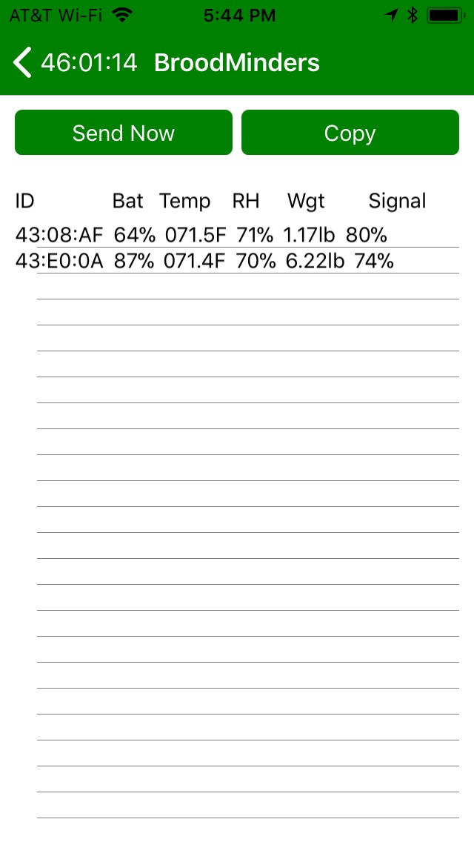

#### 9.10 WIFI/CELL App CELL Network Screen

**NOTE:** These are commands to the CELL modem. See the next page for Wifi commands. If the modem is not on, invoking a command will turn it on. Give it a few seconds and then try the command again. The result will be printed at the bottom of the screen.

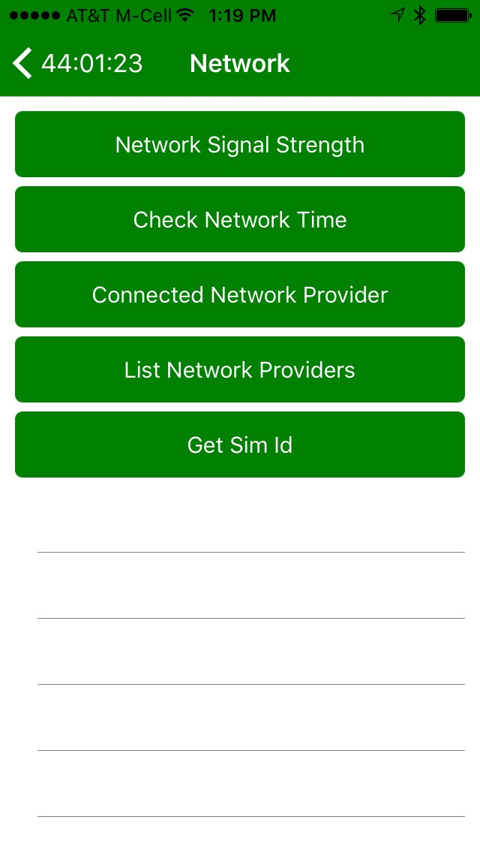

**Network Signal Strength –** for reliable operation, it should be 4, (maybe 5) or more.

**Check Network Time –** Time from the WIFI/CELL network

**Connected Network Provider –** Typically ATT but may be others

**List Network Providers –** See all the providers in the area.

**Get SIM ID –** This should match the number stickered inside the enclosure.

#### 9.11 BroodMinder-WIFI/CELL App WIFI/CELL Network Screen

**SSID –** Make sure that capitalization matches your network name.

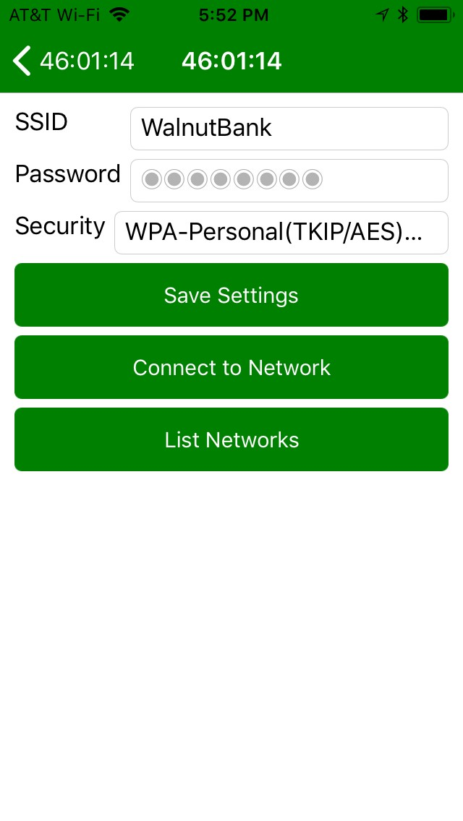

**Password –** Password for your network

**Security –** Typically WPA-Personal but may be none or

WEP

**List Network**

## 10 Data Interpretation

In this section, we present some initial findings from Theo’s hives. We are still very much in the learning mode and will appreciate your observations shared on the BroodMinder forum at BroodMinder.com.

We are constantly posting updates and videos at at[BroodMinder.com/pages/videos.](https://broodminder.com/pages/videos) Be sure to check there.

These reports were written in the summer of 2016. You can look directly at the data in MyBroodMinder.com by looking in the Claypoint apiary. This is available as a demo apiary.

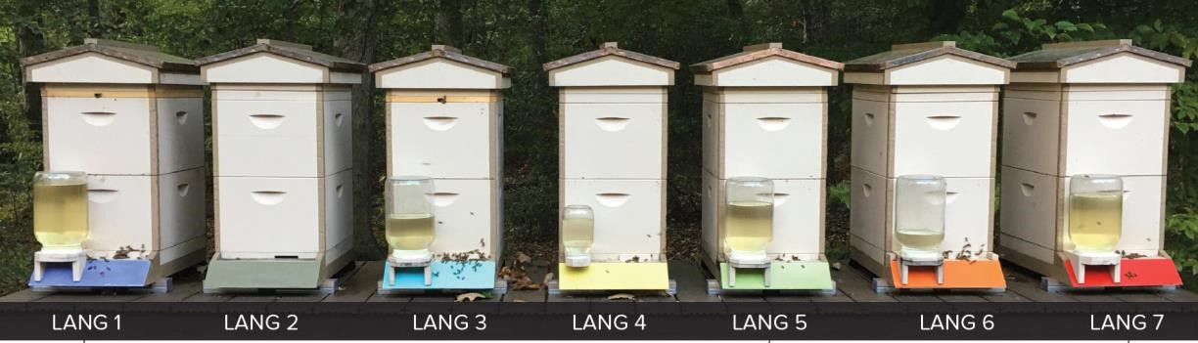

Reports

5.1 Hive Weight Profiles

5.2 Swarm Detection with a BroodMinder TH Device in a Top Bar Hive

5.3 Avoiding Excessive Heat in the Hive During Summer Months

5.4 Detection of Cluster/Queen Movement and Spring Brood Buildup

5.5 Pull the Supers When the Dearth Hits

5.6 Promising Citizen Science Project Observations

5.7 Using BroodMinder Data to Optimize Hive Preparation for Winter

### 10.1 Hive Weight Profiles

By Ray Walker, May 2016

Hive weight trend charts contain repetitive shapes or profiles, depending on the season, floral resources, rainfall, temperature, humidity and other variables. By studying weight profiles, beekeepers can learn more about their apiary’s foraging resources, colony’s status, health and performance. Daily, weekly and monthly profiles of each colony can be compared with “typical” weight profiles for an apiary’s local environment (based on historical scale trend data).

Hive weight trend data can be used to estimate bee populations, nectar collection and consumption rates, accumulated foraging hours, foraging performance and other colony characteristics.

During the past 3 years, I’ve been applying a variety of electronic hive scale systems to study and compile a library of “typical” weight profiles for my backyard apiary. Since the end of April, I’ve been using a BroodMinder hive scale prototype.

#### Monthly Profiles

The main nectar flows in northern Delaware occur during the months of May and June (typically about 50 days duration). For an overwintered nucleus colony to exploit the main flow, it’s population must increase rapidly in March and April – peaking just before the flow begins.

Weather conditions have a big impact on how well the colony’s foraging population collects nectar from the variety of available blooms. Flying conditions (rain, wind, temperature, humidity, etc.) must be ideal when blooms are pervasive to maximize monthly foraging rate. By examining the shapes of the monthly profiles and observing when specific blooms occur, the major nectar resources for the apiary location can be determined (and compared year-to-year).

#### Monthly Trend Chart

Early May’s cooler temperatures (50-60’s) and rain limited foraging rates.

Increased daytime temperatures (70-80’s) and less rainfall improved flying conditions during the end of the month. Best foraging rates were obtained when the bloom’s nectary had warm day-time and cool night-time temperature cycles. The colony foraged ~90 pounds of nectar in the month (~3 pounds per day). Black locust and tulip-tree were both blooming during the end of May.

#### Weekly Profiles

By charting the week of maximum nectar flow, a series of repetitive profiles show routine day-time weight gains as nectar is collected then night-time weight losses as nectar is evaporated and the colony is consumes nectar. By comparing this season’s maximum weekly profile to previous season’s maximum weekly profile, a relative comparison of colony foraging performance is obtained.

Weekly profiles of maximum weight gains can be added to a library of trend charts for evaluating an apiary’s foraging capability to other apiary location’s capability.

#### Weekly Trend Chart

Increased average temperature cycles with wider spreads in day & night temperatures as well as stable/lowest humidity produced the maximum nectar flow.

The average foraging rate for the best four days was about 10 pounds per day. This rate compares to previous year’s foraging rates. However, the maximum nectar flow duration varies from year to year.

#### Daily Profiles

By charting the day(s) of maximum nectar flow, the typical daily routine of the colony can be studied. The colony’s initial foraging flights occur at the same time each morning. Several foraging “missions” can be observed as the weight increases at various rates (depending on which blooms are available at different times of the day). Towards evening, the foraging force returns to the hive and the weight peaks for the day. During the night-time, moisture from the nectar is evaporated and bees consume nectar.

#### Daily Trend Chart

Daily profiles indicate which portions of the day-time hours the foragers are most active – providing the beekeeper insight when hive inspections would be most disruptive.

### 10.2 Swarm Detection with a BroodMinder TH Device in a Top Bar Hive

By Theo Hartmann, June 2016

This is a case where a BroodMinder TH device in a top bar hive was helpful in tracking the progress of the

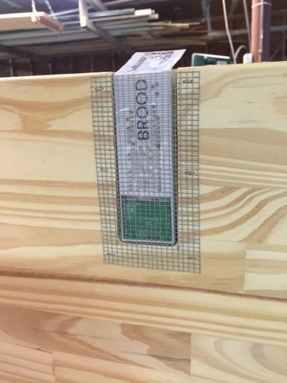colony in a remote hive. The BroodMinder Temperature and Humidity Device was installed in a recess in the end board.

The colony was installed from a swarm into this hive and then moved to a remote location. My remote agent was kind enough to obtain the data from the BM device on a daily basis and upload it to MyBroodMinder.com

Below is a screen shot from MyBroodMinder.com showing the entire time period since the colony was in this hive:

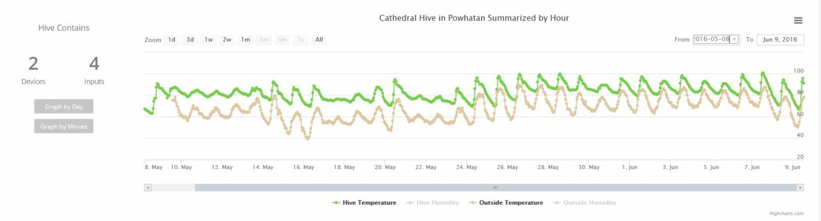

Because of the nature of this hive and the location of the device at one end of the hive, it is not expected that the measured hive temperature stays at one level as it is the case in a Langstroth hive. What caught my eye were the last two days where the temperature dropped to the lowest level since the bees were introduced into this hive.

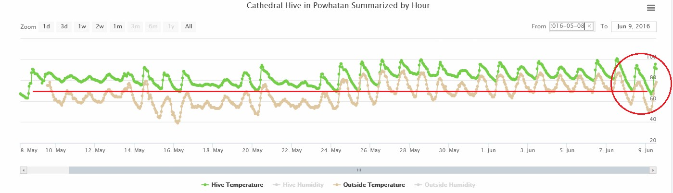

Granted, ambient temperature dropped, too but going back to May 16th, ambient temperatures were lower back then at the same or higher hive temperatures. I concluded from this that the colony had swarmed because lower temperature means less heat generated means less bees inside the hive to generate heat and keep the hive temperature at a higher level at night. I went there for an inspection and this is what I found:

Few bees on the

comb and two

open swarm

cells at the

bottom of two

combs.

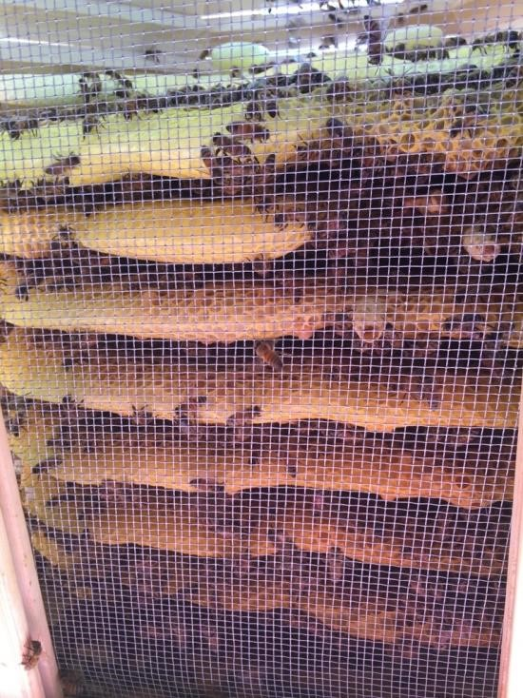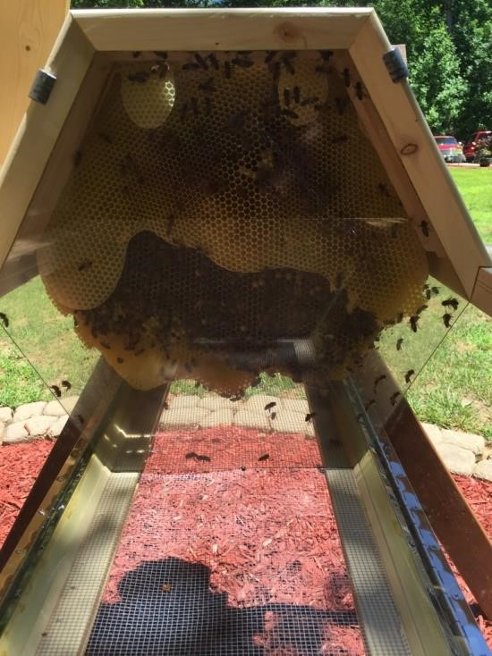

Clearly, a lot of bees have moved out to find a home elsewhere. This is not necessarily a bad thing because the bees which are left behind have ample resources in the hive (pollen, nectar, honey). The natural process of queen replacement has already begun since two new queens have hatched as evident from the open swarm cells. Also, the mite count in this hive will drop since the brood cycle has been interrupted.

The BroodMinder TH device together with a remote agent and MyBroodMinder.com proved to be effective tools to monitor this hive in a remote location.

### 10.3 Avoiding Excessive Heat in the Hive During Summer Months

By Theo Hartmann, June 2016

This document describes findings on two hives which were started this spring. One was from package and the other one was a small swarm. Both colonies were introduced into Langstroth 8-frame deep box hives and were developing at a more on less identical pace and both hives were expanded to two brood boxes per hive pretty quickly. The BroodMinder Temperature and Humidity devices (TH) were placed on top of the upper brood box. There is no super above that, just the inner and outer covers. Temperature peaks started to appear on June 6th at times when the mid-day sun was hitting the outer cover of the hives as can be seen on the chart below.

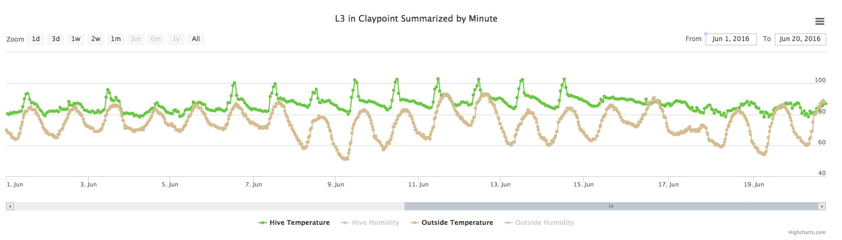

The peaks would reach 100+F almost every day between June 6th and June 15th. At times, these temperatures were 20F above ambient temperature and clearly, this must have put unnecessary stress on the bees. The hives essentially became greenhouses. This was surprising because both hives have screened bottom boards and screened and ventilated inner covers for the summer months. A 2” high density Styrofoam insulation was placed on top of the screened and ventilated inner cover on the starter hives on June 15th. This resulted in elimination of the temperature peaks.

For comparison, here is a temperature profile from a mature hive with honey supers:

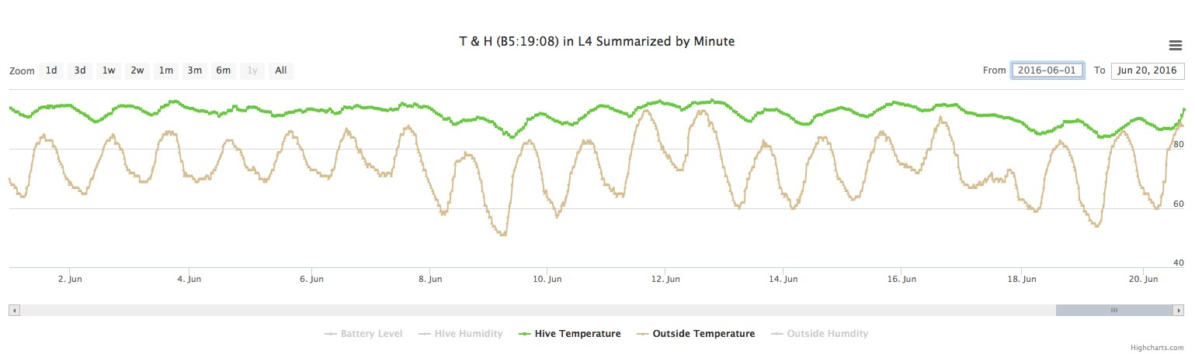

No peaks and a more mellow change in temperature.

These same to charts are shown again below and a few additional things can be concluded from them:





Notice that the difference between the hive temperature and ambient temperature generally is smaller for the starter hive (top) compared to the established hive (bottom). The reason is the number of bees in the hive. The starter colony is affected much more by changes in ambient temperature than the established colony.

The more gradual change in temperature on the established hive can be attributed to the fact that there are two honey supers above the TH device. These supers shield the brood nest from the temperature peaks seen in the hive which does not have any supers. The very top of the hive with the supers sees the same temperature peaks observed in the starter hives but these peaks never make it down to the TH device.

This discovery and subsequent corrective action was only possible because:

* BroodMinder TH devices are installed
* Data are collected on an hourly interval
* Plots of the data available instantly on MyBroodMinder.com
* Local weather data were added by MyBroodMinder.com for reference

The cost to do this analysis is the purchase price of the BroodMinder device, nothing more. All the other data and analysis tools are available to BroodMinder users for free.

### 10.4 Detection of Cluster/Queen Movement and Spring Brood Buildup

By Theo Hartmann, June 2016

This example shows how multiple BroodMinder devices in the same hive can be used to detect a number of things without actually opening the hive for physical inspection.

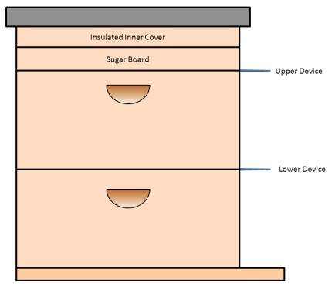The setup is a 8-frame Langstorth hive with two deep brood boxes, screened (but closed) bottom board, sugar board with top entrance above the top box, insulated inner cover and outer cover.

This was the configuration of the hive going into the winter. One BroodMinder TH device was installed between the top brood box and the sugar board and second BroodMinder T device was installed between the two brood boxes. MyBroodMinder.com was still in it’s infancy at the time the test went underway and for this reason; another BroodMinder TH device was placed outside in a protected

area to gather ambient conditions.

Here is an overview of the data collected. The green line represents the temperature above the top box, the red line the temperature of the bottom box and the dotted line is the ambient temperature.

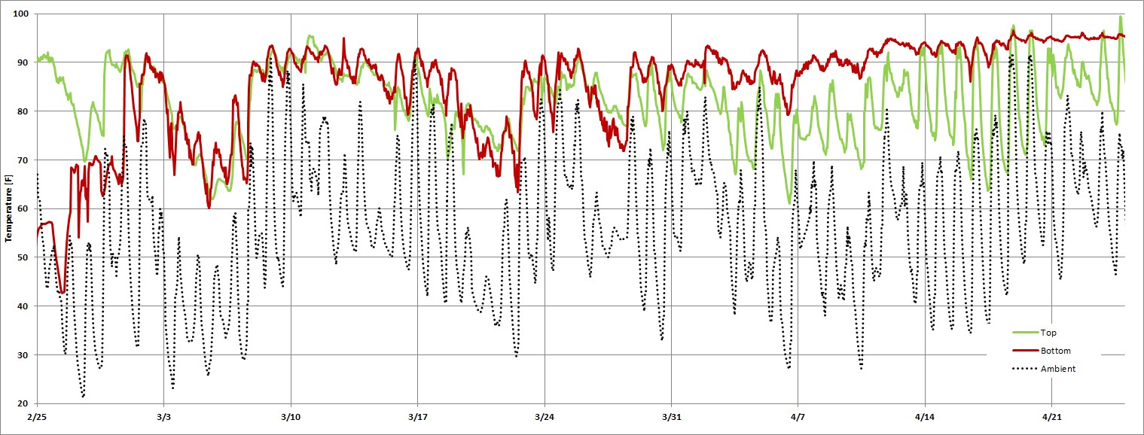

This chart is broken down in sections for a closer look at the data and corresponding analysis.

|  |
| --- |
| Higher temperatures in the top box indicated that the cluster is up there feeding on honey stores and sugar. |

|  |
| --- |
| Temperatures equalize between the boxes but are not high enough for brood to develop. |

|  |
| --- |
| Both boxes are getting warmer which could be a sign that the queen started laying, potentially in both boxes |

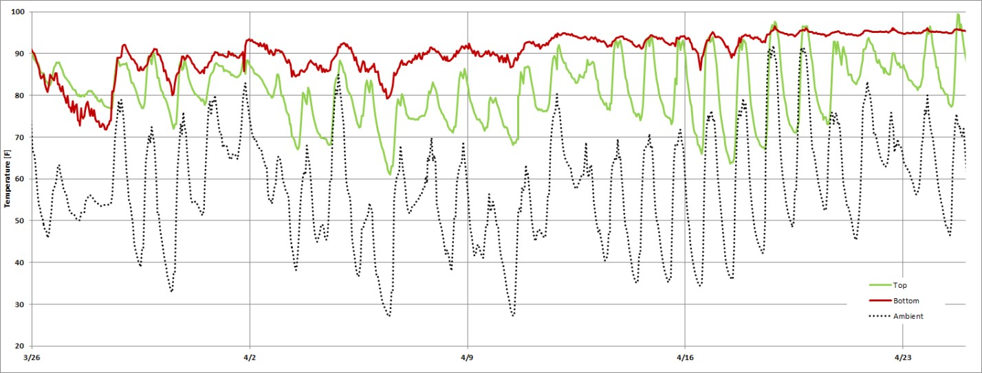

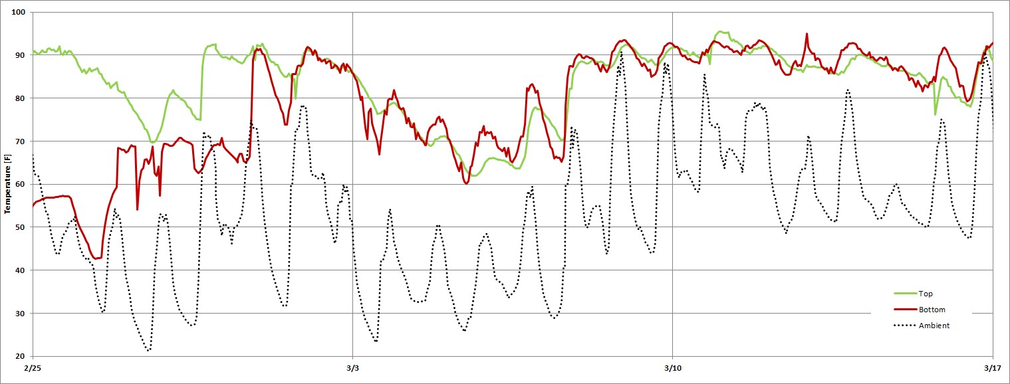

Here a switch happens and the The bottom box is now kept at 90+F. Perfect conditions for brood to bottom box begins to get develop. The top box follows the ambient temperature swings. Not warmer than the top indication many bees up there.

that the queen has moved down into the lower box.

These data indicate a healthy hive and a subsequent inspection revealed that this is in fact the case and the colony is ready for the nectar flow.

### 10.5 Pull the Supers When the Dearth Hits

By Theo Hartmann, July 2016

Every spring it is a pleasure for beekeepers to watch the bees going on their daily excursions and bringing back pollen and nectar. As we all know, this is to both feed the larva and also to produce honey stores for the next winter for the colony to feed on. Having the hive weight available is a great help in making the decision when to harvest honey from the hive. There is a spring nectar flow which can produce large amounts of honey in a short time as seen in the charts copied from the mobile app below. The hive weight increased rapidly during the second part of May.

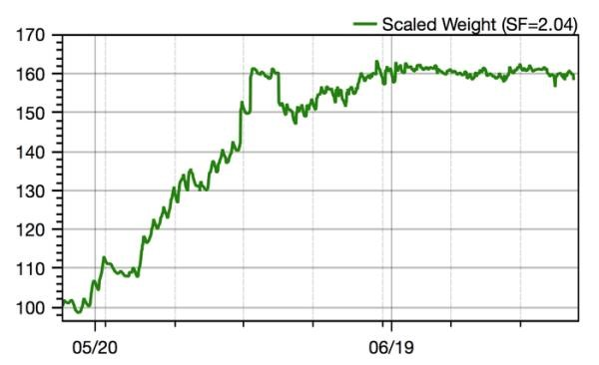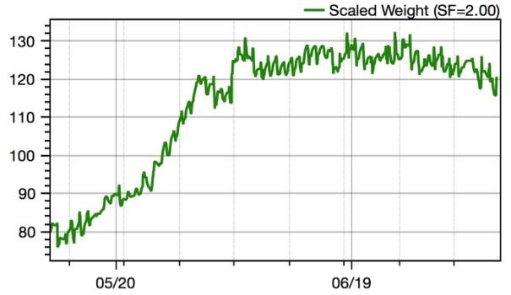

There are the daily ripples caused by the bees bringing in nectar during the day causing weight increase. Then, during the night, bees are busy reducing the water content and the hive weight decreases. There also are the larger jumps where the beekeeper added or removed frames or supers.

Longer term, the weight increase clearly ceased middle of June. The hive on the right even shows a decreasing trend in hive weight. This is a clear sign that the dearth has set in and there is not enough natural food available. The bees begin to consume the honey stores or ever worse, robbers grab what they can get. Below is a chart of such a situation.

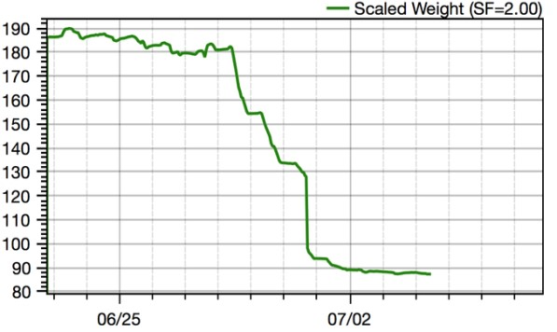The hive weighed a whopping 185lb when the dearth hit. Then, on June 28th the weight started to drop like a rock. It stabilized at about 155lb the next night. 30lb lost. The following day, again massive weight loss took place down to 133lb, another 22lb lost. The weight loss continued the following day until the beekeeper removed the honey supers and got the hive under control. The robbers knew exactly what they were doing after they discovered the venerable hive. Take out what we can the first day, take a rest and then go back for more, day after day. There was no other hive with a scale nearby otherwise we would probably see where the loot went!

The above makes it clear that honey supers should be removed when the dearth hits, latest when the hive weight starts to decline. The BroodMinder-W scale is of great help to time the removal of the honey super(s). This will not only mitigate the robbing risk but also increases the bee density in the hive and the ability for the colony to defend their hive. It is also the time to install an entrance reducer and/or screens and close off any top entrances. With these measures, the robbing risk is minimized.

Here is an additional tip for BroodMinder-W users:

Removal of a full honey super results in a reduction of the hive weight by 40-60lbs which is a significant portion of the total hive weight. This is an excellent opportunity to get information for adjustment of the hive scale factor in the mobile app. Therefore, weigh everything you have removed from the hive as accurate as you can with a bathroom scale, a postal scale etc. and record it. Visit the BroodMinder forum for advice on how to adjust the hive scale factor.

Getting back to the dearth, food is scarce for the bees during the dearth period and they may require supplemental feeding. Knowing the hive weight of established colonies is essential to determine if it is necessary or not. First year colonies require feeding irrespective of the hive weight.

On established colonies I would recommend to start feeding if the hive weight starts to drop. This will reduce stress in the colony since the food is readily available inside the hive. This is substitute food for the lack of nectar out there. Stop feeding when the hive weight increases. The bees have found another nectar flow.

When feeding in the summer I use 2:1 Sugar syrup. My thought is that a 1:1 is good for spring to get the queen thinking that there is a nectar flow and she will lay more eggs. In the summer and after the spring nectar flow is over, the bees are busy making honey out of the nectar they collected. During this process, the bees remove vast amounts of water from the honey before they can apply their seal of approval and cap the cells with an airtight wax cap. The last thing the beekeeper wants to do is give them more water. So, thicker syrup is better in the heat of the summer. Hint: Add 2 tbsp per gallon (1/2 tbsp per quart) of apple cider vinegar to the syrup. This lowers the PH to the level of honey and prevents black mold.

### 10.6 Promising Citizen Science Project Observations

By Theo Hartmann, August 2016

As an early adopter of the Citizen Science (CS) Project, I have seven hives set up in this configuration and data are collected on all of them on an hourly basis. This paper illustrates the power of this setup where multiple hives can be compared on an even basis to detect anomalies and define resulting actions.

True to their name, BroodMinder devices detect the presence of brood: The measured temperatures show that the bees hold the nest temperature at a constant 95-96°F when good brood is present. The charts below show both, the superb job the bees are doing raising babies and also the quality of the BM devices showing exact temperatures.

Hive with spotty brood in the bottom box Hive with 5+ frames of solid brood in the bottom box

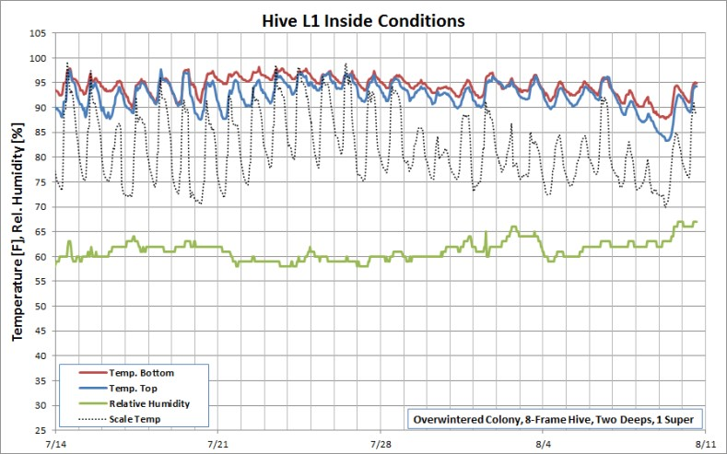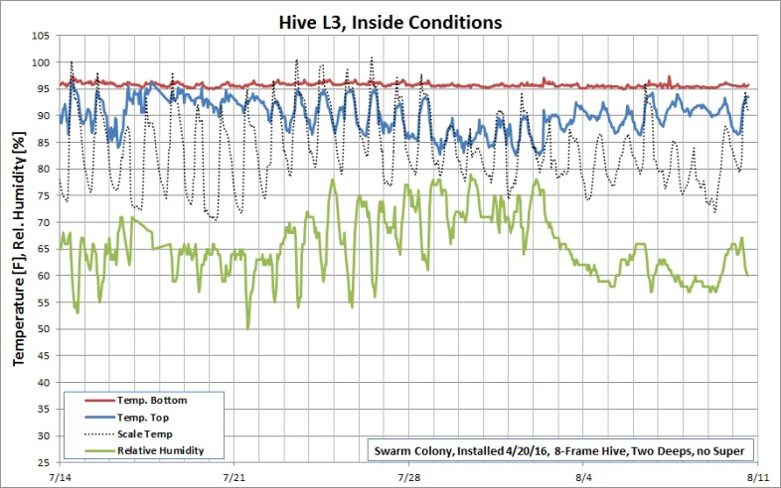

Hive with 5+ frames of brood in both brood boxes Requeened hive finally coming “on-line” properly

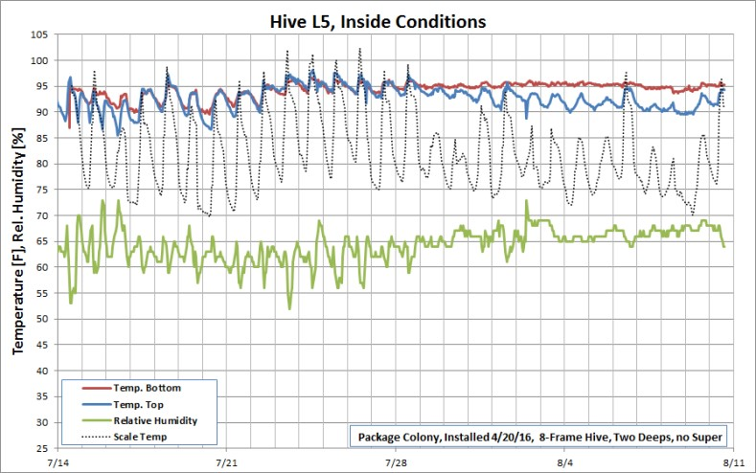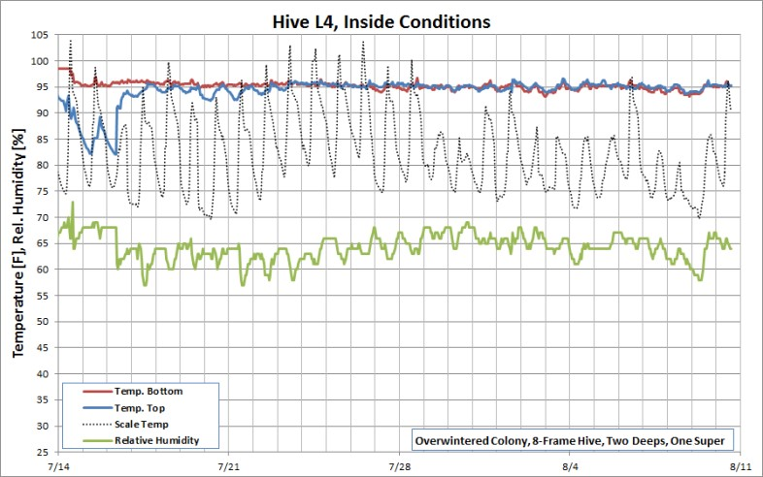

### 10.7 Using BroodMinder Data to Optimize Hive Preparation for Winter

By Theo Hartmann, October 2016

This is the time of year when beekeepers are preparing their hives for the winter season. There are a few essential steps which typically take place:

1. Ensure adequate resource levels in the hives to be overwintered
2. Ensure that each hive has a laying queen and the brood nest in the bottom box and resources around and above it.
3. Consolidate weak hives for the winter and split them in the spring

Below are a few examples from my apiary showing how BroodMinder data help to plan the hive inspections and hive configuration changes to accomplish the above goals. The apiary discussed here has six active hives next to each other. Hive 2 is a control hive without bees. All hives are configured the same with two 8-frame deep boxes. Supers have been removed earlier and all colonies are fed with Boardman style entrance feeders. The combined weight of each hive hardware is just under 50lbs.

1. Using Measured Hive Weight to Determine Resource Allocation

The goal is to have about 60lb of resources in each hive going into the winter. This consists of capped and uncapped honey, pollen and supplemental food as needed. The situation as found after the summer is as follows:

|  |  |  |  |  |  |  |  |
| --- | --- | --- | --- | --- | --- | --- | --- |
| Hive | # | 1 | 3 | 4 | 5 | 6 | 7 |
| Gross Weight | lb | 100 | 130 | 70 | 100 | 80 | 80 |
| Hardware | lb | 50 | 50 | 50 | 50 | 50 | 50 |
| Net Weight | lb | 50 | 80 | 20 | 50 | 30 | 30 |
| Over/Under | lb | (10) | 20 | (40) | (10) | (30) | (30) |

Only hive 3 fulfills the 60lb resource requirement. All others need help. It was decided to remove some of the excess honey from hive 3 (4 frames) and put it in hive 4 (2 frames), hive 6 (1 frame) and hive 7 (1 frame). This resulted in this revised weight distribution:

|  |  |  |  |  |  |  |  |
| --- | --- | --- | --- | --- | --- | --- | --- |
| Hive | # | 1 | 3 | 4 | 5 | 6 | 7 |
| Gross Weight | lb | 100 | 110 | 85 | 100 | 85 | 90 |
| Hardware | lb | 50 | 50 | 50 | 50 | 50 | 50 |
| Net Weight | lb | 50 | 60 | 35 | 50 | 35 | 40 |
| Over/Under | lb | (10) | 0 | (25) | (10) | (25) | (20) |

Most hives are still short of the 60lb resource goal.

1. Using Brood Box Temperature to Detect Queen Presence and Brood Nest Location

Hive temperatures indicate that the queens have slowed down their laying rates, which is normal for this time of year.

Below is an example to show this condition. The bee colony kept both brood boxes at around 96F until the end of September. Then the bottom box dropped off followed by the upper one. This would indicate that the queen stopped laying in the bottom box first followed by the top one. Beekeepers who use Oxalic acid to reduce the Varroah mite count in their hives can use this temperature drop as a trigger to start treating their hives because from that point forward there will be a minimal number of capped brood cells in the hive.

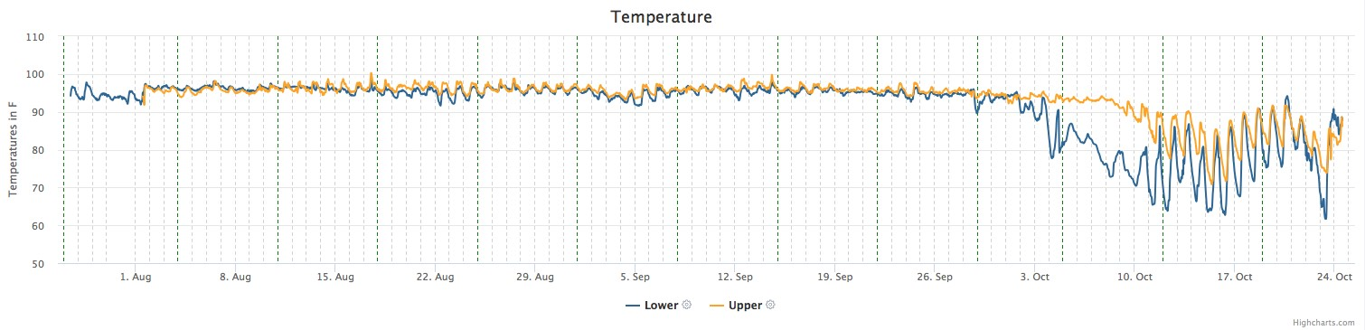

Taking a snapshot of the temperature levels before the queen laying rate started to decrease showed the following:

|  |  |  |  |  |  |  |  |
| --- | --- | --- | --- | --- | --- | --- | --- |
| Hive | # | 1 | 3 | 4 | 5 | 6 | 7 |
| Upper Temp | F | <90 | <90 | >90 | <90 | >90 | <90 |
| Lower Temp | F | <90 | >90 | >90 | >90 | <90 | >90 |

This was around the beginning of October

90F was taken as a threshold to determine brood/queen presence. The hive inspections confirmed open brood presence in the boxes indicated in green above and no or very little capped brood in the boxes shown in red.

3) Hive Reconfiguration and Consolidation

The following actions will be taken or were taken already:

Hive 1: Queenless hive. The two boxes will be combined with hives 4 and 6. Hive 1 will be closed for the winter.

Hive 3: No configuration change

Hive 4: Combine brood from both boxes to the bottom box. This creates a smaller brood location, easier to keep warm

Hive 5: No configuration change

Hive 6: Move brood to the bottom box

Hive 7: No configuration change

All live hives will get a 20lb sugar board with top entrance. This will take care of the missing resources. They also get a 2” Styrofoam hive top insulation. Bottom entrances will be reduced to ¾” width, screened bottom boards will be closed and the Boardman entrance feeders will be removed.

Good night girls. Sleep well and see you in the spring!

All detailed charts from these hives can be viewed in the demo account of MyBroodMinder.com, use link below

[http://app.MyBroodMinder.com/apiary/detail/bEz8YnexZpjyiMd6s7lSFvqGVKkaIAP5](http://app.beekeeping.io/apiary/detail/bEz8YnexZpjyiMd6s7lSFvqGVKkaIAP5)

## 11 Appendices

### 11.1 Appendix A - BroodMinder-W physics

There are many ways the BroodMinder hive scale can be used and since it only measures a fraction of the total hive weight, the design and placement of the auxiliary support and the BroodMinder scale positioning becomes an integral part of the total hive weight measuring system. Generally, the more effort is put into this, the better the results will be. The hive support systems shown below start from the easiest to the most sophisticated with highest uncertainty to lowest. It is up the individual user to decide what to implement.

*NOTE: the most typical error source is inadequate support under the scale. This can result in strange behavior as the hive flexes as it expands and contracts due to sun, rain, temperature, etc. Providing a flat support will improve results. An easy fix is to place a ¾” plywood sheet (or equivalent) under the scales.*

*ADDITIONAL NOTE: If all you want to see is honey flow, good support is not required. You will just have to ignore the daily fluctuations. You will still be able to observe the overall change in weight.*

a) Default Arrangement

This is the default arrangement with the scale at the front of the hive and a 2×4 as an auxiliary support (fulcrum) at the back:

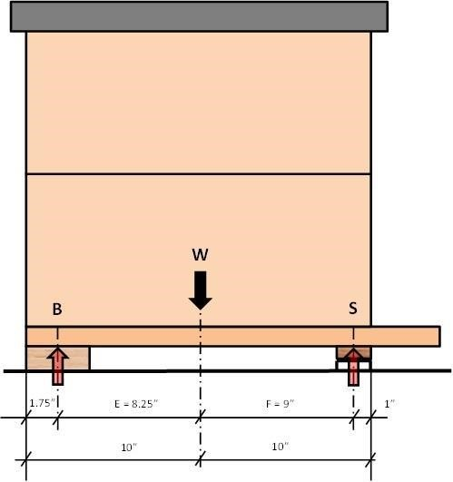

Here are some calculations surrounding the setup:

Assumptions

The hive weight W is distributed evenly and the center of gravity is in the middle of the hive. For simplicity, the front overhang of the bottom board is not considered. Hive weight is assumed to be 100%.

Calculations

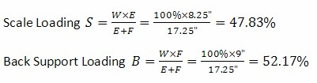

When using standard 2×4 lumber as a back support and aligning it with the back of the hive, the total hive weight W can be calculated from the weight on the scale S as:



Therefore, use 2.09 as the default hive scale factor in the app if you are using this setup. This of course can be fine tuned once some weight measurement are available.

The chart below shows the scale correction factor for different scale and fulcrum arrangements. The X-Axis is the position of the fulcrum point in inches from the back of the hive. The different lines represent the scale centerline position in inches from the back of the hive. Arrows show the example above.

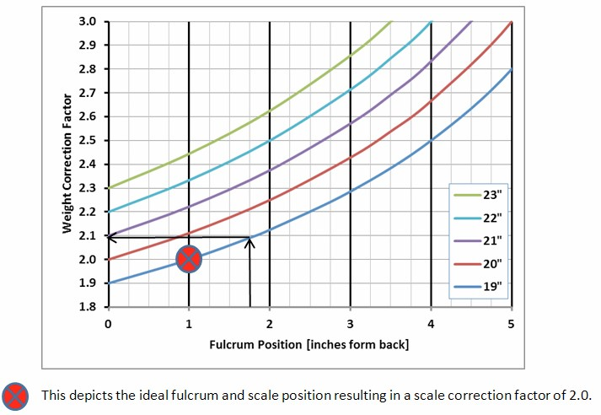

1. Alternate Arrangement 1

Based on the above, the auxiliary support should be placed 1” from the back of the hive. It is recommended to attach a trim piece on top of the 2×4. This will help for accurate positioning of the auxiliary support.

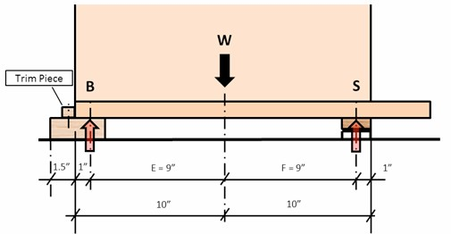

Now we have equal moment arms E and F and the hive scale correction factor becomes 2.0 which is the default in the mobile app. There are however some other influence factors which should not be overlooked. The real fulcrum point of the auxiliary support is anywhere between the back of the hive and the front of the aux support due to variations of the support system levelness and potential warpage of the 2×4 itself.

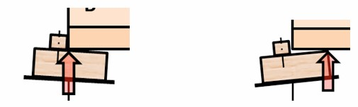

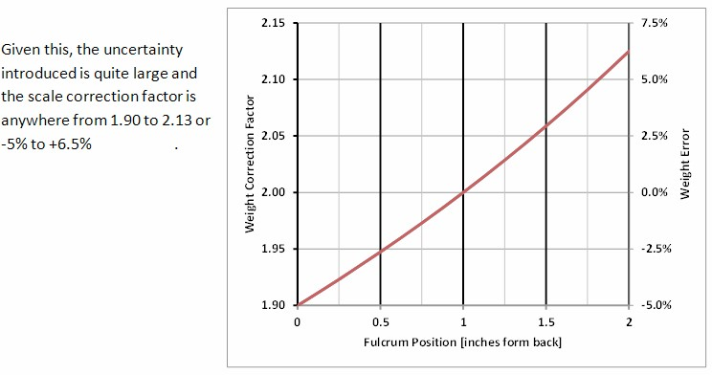

1. Alternate Arrangement 2

A different support system can be used which has a defined fulcrum point and is not affected by the alignment of the support structure:

Take a piece of pine or oak, about ¾” thick and 2” wide. Length needs to be the width of the hive. Cut a small kerf into it. The kerf needs to be as deep as the width of the saw blade. Attach this piece to the underside of the bottom board of the hive. Align it flush with the back. Then place a piece of 1” by 1/8” 6061 or 6063 aluminum angle, same length as the wood strip, under it to support the hive. The corner of the aluminum angle rests in the kerf. The total hight of the aluminum angle and the wood needs to be equal or slightly bigger than the scale height to ensure the hive is level or even slightly tilted forward to ensure water drainage away from the hive entrance.

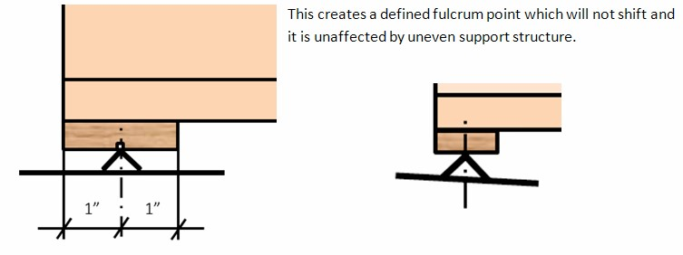 d) Lateral Balancing

All of the above support systems are affected by undefined lateral weight shift since the hive is resting on more than three points. There are two points at the front inside the hive scale and a linear support at the back of the hive. This could lead to overload on one of the load cells in the scale and therefore, lateral balancing is typically required if the support system under the hive is not one continuous platform, i.e. separate cinder blocks for the front and the back of the hive.

Read the weight from each load cell individually by switching to the real time display with the app. In this mode, the weight on the scale is shown as %Left, % Right. The right hand side of the scale is the side with the device identification sticker. No further action is required if the L/R difference is less than 10%.

If not then shim the scale on the side with the lower weight reading until the weight readings match. Alternatively, shimming can also be done under the back support on the opposite side of the low weight reading.

1. 3-Point Hive Support

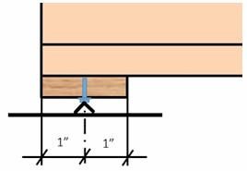

There is a way to alleviate the need for lateral balancing by introducing a true 3-point support system. The parts are similar to the ones used in arrangement 2 but instead of using a 1” angle, for this arrangement you will need a ¾” angle. A 7/32” hole is drilled in the middle of the board instead of cutting a kerf. A ¼” x 0.5” slotted machine screw is used as center support. The screw will cut its own threads into the board. The slot in the screw head is aligned so that it can rest on the edge of the aluminum angle in a single point without sliding off.

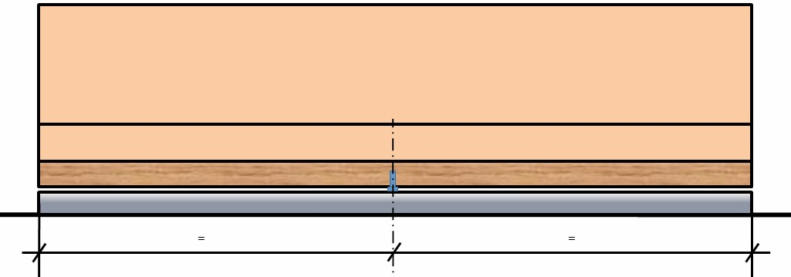

There is a small gap between the aluminum angle and the wood board. It has to be ensured that this gap is even width across the hive. The screw in the middle should be the only contact point. This will ensure that the correct weight is measured and at the same time it is the “safety net” against the hive falling over if excessive uneven loading is taking place, i.e during hive inspections.

1. BroodMinder Scale Positioning

Most of the above has been dealing with the auxiliary support. Let’s focus now on the scale positioning.

As shown in the previous sections, it is desirable to have the front face of the scale placed in line with the front face of the hive body. Moving it further in would improve accuracy at the expense of hive stability and moving it further out would reduce accuracy with little improved hive stability.

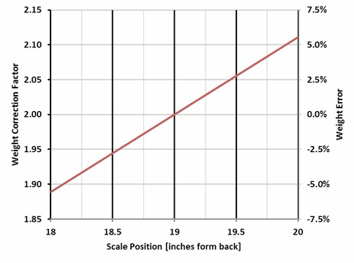

This chart shows the influence of scale placement on the scale correction factor and scale error introduced due to inaccurate positioning of the scale. The influence is 5.6% per inch

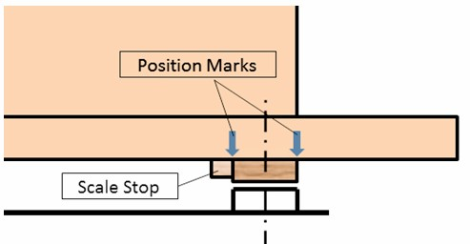

It is advisable to mark the scale position on the bottom board of the hive or to attach a mechanical stop. This will help to put the scale back into the same location after it has been pulled for a battery change or some other reason.

### 11.2 Appendix B – BLE advertising protocol

For those brave souls with the gumption to create their own data harvesting equipment, we provide information on the BLE advertising protocol that BroodMinder uses. Indeed our own BroodMindewrCELL uses the advertising to eavesdrop on the devices and then forward the data directly to MyBroodMinder.com.

Advertising Packet Makeup for BroodMinder

When you read advertising packets from BLE, you can identify BroodMinder products by looking at the following.

The data will look something like this. – this example is from device 43:30:07

GAP Scan Response Event ------------------------------------------------------------------------------------

ble_evt_gap_scan_response: rssi=-77, packet_type=0, sender=[ 07 30 43 80 07 00 ], address_type=0, bond=255, data=[ 02 01 06 02 0a 03 18 ff 8d 02 2b 15 02 00 02 21 00 d0 62 00 ff 7f 05 80 37 07 30 43 00 00 00 ]

Values are in decimal unless preceded with 0x

1. Check for "Manufacturer Specific Data" flag

Bytes 6,7 = 0x18, 0xff

1. Check for IF, LLC as the manufacturer

Bytes 8,9 = 0x8d, 0x02

1. Bytes 10-29 are the data from the BroodMinder as outlined below. deviceModelIFllc_1 = 0x2b (43d = scale) DeviceVersionMinor_1 = 0x15 (21d)

DeviceVersionMajor_1 = 0x02 (FW 2.21)

Elapsed_2V2 = 0x21 (33d)

Temperature_2V2 = 0x62d0

WeightL_2V2 = 0x7FFF

WeightR_2V2 = 0x8005

UUID_3V2 = 43:30:07

Here is C# code to extract the info. It should be easily adapted to your language of choice. Just pay attention to the byte numbers.

----------------------------------------------------------- int byteNumAdvdeviceModelIFllc_1 = 10; int byteNumAdvDeviceVersionMinor_1 = 11; int byteNumAdvDeviceVersionMajor_1 = 12; int byteNumAdvBattery_1 = 14; int byteNumAdvElapsed_2 = 15; int byteNumAdvTemperature_2 = 17;

int byteNumAdvHumidity_1 = 24; int byteNumAdvElapsed_2V2 = 15; int byteNumAdvTemperature_2V2 = 17; int byteNumAdvWeightL_2V2 = 20; int byteNumAdvWeightR_2V2 = 22;

int byteNumAdvHumidity_1V2 = 24

int byteNumAdvUUID_3V2 = 25

// Version 2 advertising

batteryPercent = e.data[byteNumAdvBattery];

Elapsed = e.data[byteNumAdvElapsed_2V2] + (e.data[byteNumAdvElapsed_2V2 + 1] << 8);

temperatureDegreesF = e.data[byteNumAdvTemperature_2V2] + (e.data[byteNumAdvTemperature_2V2 + 1] << 8);

MODEL 41 (Temperature only device)

temperatureDegreesF = (temperatureDegreesF / Math.Pow(2, 16) * 165 - 40) * 9 / 5 + 32;

MODEL 42 (Temperature/Humidity device)

temperatureDegreesF = (-49 + 315 * (rawTemp / (Math.Pow (2, 16) - 1)));

humidityPercent = e.data[byteNumAdvHumidity_1V2];

weightL = e.data[byteNumAdvWeightL_2V2+1] * 256 + e.data[byteNumAdvWeightL_2V2 + 0] -32767;

weightScaledL = weightL / 100;

weightR = e.data[byteNumAdvWeightR_2V2 + 1] * 256 + e.data[byteNumAdvWeightR_2V2 + 0] - 32767;

weightScaledR = weightR / 100;

weightScaledTotal = weightScaledL + weightScaledR;

### 11.3 Appendix C – App updates

Here is a running log of app updates starting in June of 2018.

#### 9.3.1 BroodMinder / BroodMinder Lite

• Version 2.90

o Fix a bug where first time users workflow for creating hives can go wrong.

* Block Android devices going to sleep during HbH retrieval
* Reduce the font on the graph page for smaller Android phones
* Add more videos to startup help
* Improve error catching
* Misc cosmetic fixes
* Major update for all compilers, tools, and Apple OS

• Version 2.97

o Added BroodMinder-T2 support

o Corrected error in database rebuild

o Fixed erase flash for Th and W devices on Android